Citi Architecture and Technology Engineering (CATE)
Engineer and Certify D2 45P08 interface for Documentum

Script Lite Requirements
Project ID : None

Disclaimer
If printed, content is valid only for the day it was printed. Always refer to the online document for the current version. If the user elects to maintain copies of this procedure, it is their responsibility to verify the currency of the document by checking it against the online version. This document must be promptly removed from use when obsolete.

TABLE OF CONTENTS

1 Overview 4

1.1 Document Purpose 4

1.2 Revision History 5

1.3 Relevant Links 6

2 Documentation 8

2.1 Requirements Overview 8

2.1.1 User requirement 8

2.1.2 Functional requirement 8

2.1.3 Technology requirement 9
2.1.3.1 Technical Overview 9
2.1.3.2 Component Interaction 9

2.1.4 Domain Specific Requirements 10

2.2 Design Specifications 10

2.3 Testing Scope 11

2.4 Testing Strategy 12

2.4.1 Testing Constraints 13

2.4.2 Risk Identification 13

2.5 Test Lab Configuration Requirements 13

2.5.1 Test vm: vm-3bb9-c3a2 14

2.5.2 Test vm: vm-e62d-0840 + vm-d8b8-0913 15

2.5.3 Test vm: vm-5e7b-5af5 16

2.5.4 Test vm: vm-ffe0-85ab + vm-6cc6-4f27 16

2.6 Test Specifications 18

https://ecmd2.nam.nsroot.net:7080/D2 27

2.7 Summary Of Test Results 31

2.8 Defect Tracking Log 32

3 Assumption and restrictions 34

4 Architectural implications 35

5 RElease notes 36

5.1 Content Server 36

5.2 App Server 41

5.3 SSO set up 43

5.4 Dedicated JMS for Docbase using D2 44

5.5 Importing HR sample application 46

5.6 GDS package for D2 47

5.7 Configurations/Logs Directories 47

5.7.1 Content Server 47

5.7.2 App Server 48

5.7.3 SSO config 49

5.8 Sample URL 50

6 back out plans 52

7 Glossary 53

8 APPENDICES 54

8.1 FAQ 55

8.1.1 MSXML ActiveX required for D2 Config 55

8.1.2 https link works but not http link for D2 56

8.1.3 All the CS need JMS mapping to 57

8.1.4 Only D2Method.passphrase is required for lockbox 58

8.1.5 Cache clean up 59

8.1.6 How to change D2/D2 Config APP cache location 60

8.1.7 Simple way to test D2/D2 Config 60

8.1.8 D2 Config only supports IE 32bit version 62

8.1.1 How to turn debug on D2 62

8.1.2 How to add patch and handle OS upgrade 64

8.1.3 How to test D2-Config 64

Overview

Document Purpose
The purpose of the template is to provide a standard document structure for completing all requirements Engineer and Certify D2 45P03 interface for Documentum
The audience of the final document, developed from the template, is intended to be Audit, non-technical, and engineering personnel.
Documentum D2 is a web-based application that enables users to store, retrieve, and manage documents in a Documentum repository. It is highly customizable through a configuration application that does not require programming knowledge.

Documentum D2 consists of the following components:
• D2 Configuration: The web-based application, hereafter known as D2 Config, for administrators to use to configure settings such as automated content-handling processes and background settings for D2 Client. The configuration application that enables you to configure settings for security, workflows, document classification, and the client user interface.
• D2 Client: The web-based application, hereafter known as D2 Client, for users that provides the ability to interact with content in one or more repositories. The main application that is used to interact with documents in the repository.

D2 Client allows you to:
• Personalize the user interface using widgets and workspaces.
• Perform searches across one or more repositories.
• Create, import, edit, modify, and delete content.
• Organize content manually and automatically using relationships, metadata, and so on.
• Use content lifecycle and workflow processes as constructed by administrators.

Revision History
Update the document history each time a draft is issued for review.

Date | Version | Author | Author Contact Information | Change (Topic, Section, Page)
Enter the date of the update is distributed. | Indicate the document version | List the person making the change | Phone & Email | Describe the changes being made to the document. Specify the section # within the document that is being updated
10/27/2015 | 1.0 | Ming Kimball | 908-563-4322 ming.kimball@citi.com | Initial Release
10/29/2015 | 1.1 | Laxmi Molgara |  | Update Release
2/3/2016 | 1.1 | Lev Jacobson |  | Update Release
10/31/2015 | 2.0 | Mini Suri | 908-563-3301 | Final Release

Relevant Links
Provide titles and links to documentation supporting the product. These documents can be a combination of vendor documents and vendor sites (for example, Cisco). Wherever possible, vendor documents should be posted to internal sites to make sure they are accessible.

Table 1 External References (E.g., Vendors etc)
Document | URL
Installing EMC Documentum D2_4 5 1.pdf | G:\SDMS\DOCUMENTUM CERTIFICATION\D2 4.5  https://catecollaboration.citigroup.net/domains/deveng/CATEDESTE/DOCSTE/documentum/TechDocs/Installing%20EMC%20Documentum%20D2_4%205%201.pdf
HR Sample Application Instructions.pdf | G:\SDMS\DOCUMENTUM CERTIFICATION\D2 4.5  https://catecollaboration.citigroup.net/domains/deveng/CATEDESTE/DOCSTE/documentum/TechDocs/HR%20Sample%20Application%20Instructions.pdf

Table 2 Internal References
Provide a list of internal documents that have been used as an input to this document.

Provide the document name, version number and publication date. Provide hyperlinks to each document as well.

Document | Version | Date
- Steps to up SSO for D245.docx  https://catecollaboration.citigroup.net/domains/deveng/CATEDESTE/DOCSTE/documentum/TechDocs/Steps%20to%20up%20SSO%20for%20D245.docx | 1.0 | 10/01/2015
- Dedicated JMS for the Docbase with D2.docx  https://catecollaboration.citigroup.net/domains/deveng/CATEDESTE/DOCSTE/documentum/TechDocs/Dedicated%20JMS%20for%20the%20Docbase%20with%20D2.docx | 1.0 | 10/19/2015
 | x.x. | mmm/dd/yyyy

Documentation

Requirements Overview
Briefly describe the product requirements.
The overview should be a summary of the requirements in bullet format and include, at a minimum, user, functional, and technology-related requirements.
- Create CAS action to install D2 45P08 content server library
- Create CAS action to config each docbase that using D2
- Create CAS action to install D2 Config and D2 web applications
- Prove the concept of dedicated JMS for the docbase using D2

User requirement
Describe the user requirements for the product. For example, list all end-user/operational requirements in terms of appropriate scope of products feature set, end user training, skill-set required or any special requirements.
- MSXML ActiveX is a requirement to use D2 Config
- Need to have a user account that in the admingroup to be able to use D2 Config
- User account is required to use D2 client

Functional requirement
Describe the high level functional requirements. For example key data-processing requirements, platform requirements, compatibility requirements, data-manipulation requirements, communications requirements and collaboration requirements.
- D2 4.5 Patch 08
- CS 6.7 SP1
- RHEL 6.6
- Websphere 8.5.5.4
- IE 11 32 bit (citi default version 11.0.9600.17801, Update Versions:11.0.19)
- Chrome version 44.0.2403 (Citi default Version 38.0.2125.104 m)
- JRE 1.7 Update 75

Technology requirement
Describe any capacity planning tools, continuity of business requirements and the vulnerability and threat management process.
No capacity planning tools exist.
Continuity of business: this is a client application of Documentum Content Server. Have COB env build.

Technical Overview
Provide an overview of the technology, including specifications on version numbers, on where the technology fits in the overall network environment and how it scales.

This product is used inside the company network.

Component Interaction
Provide information on how the various components interact.

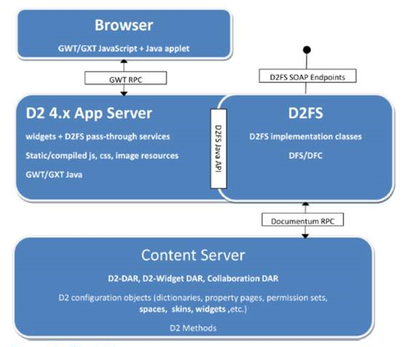
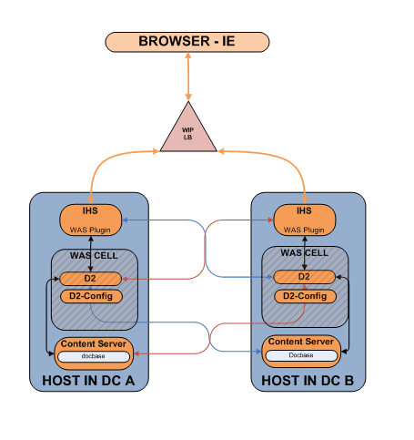

Domain Specific Requirements
Include any additional Domain specific requirements not captured above.
Verything is included above

Design Specifications
Briefly describe any design changes or updates to the existing design
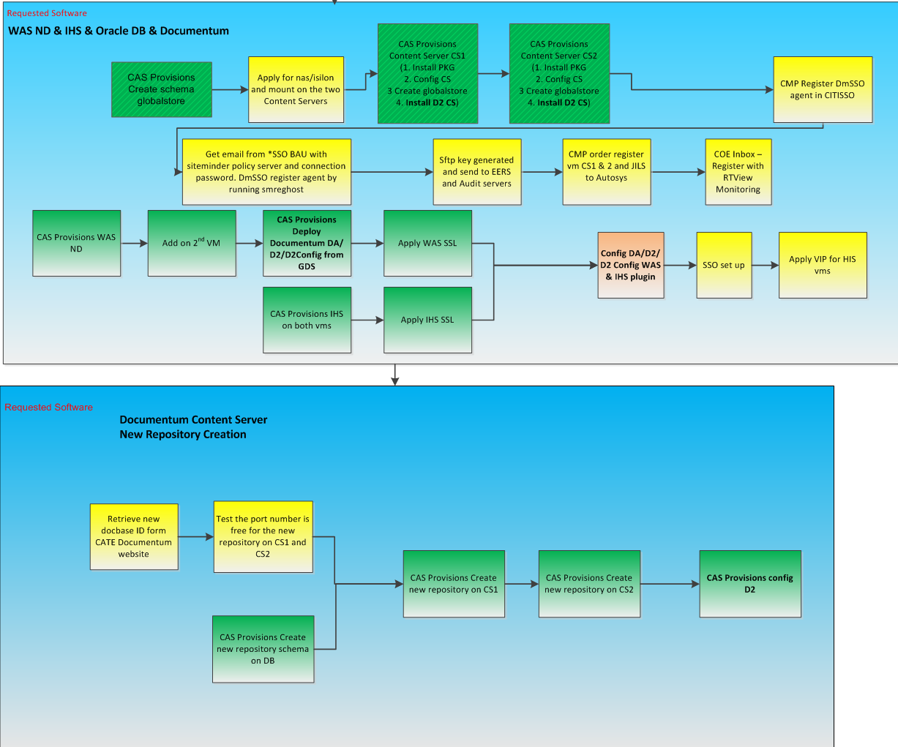

Testing Scope
Define the test plan scope.
- List issues that will be addressed in the test plan.
1 SSO login
2 JMS HA
3 Linux enviroment
- Clarify the issues that will not be addressed in the test plan.
1 AIX environment is not supported
- Please see Appendix for detailed description of each Test category.

Test Category | Test Category Required  (Yes or No) | Test Dates
Unit Testing | yes | 7/15/2015
Integration Testing | yes | 7/30/2015
System Testing | no
Performance Testing | no
Contingency Testing | no
Component Testing | no
Compatibility Testing | no
Security Testing | yes | 10/27/2015
Stress Testing | no
Regression Testing | no
Other Testing

Testing Strategy
Describe the testing strategy.
The strategy must include:
- Entry and Exit criteria – login and logout
- System tests on all new functionality – new client, see test cases
- Duplicate production data in the test environment – this will be in UAT test
- Functional testing approach based on externally observable behaviour, also termed Black Box or behavioural testing – see test case
Feature-by-feature behaviour validation, using normal and erroneous input data – see test case
- Business requirement testing – this will be in uat test
- Detailed results analysis – see test cases
- Required Tools – D2 client
- Required Support – OPS/ENG
- Test Schedule – 24 x 7

Testing Constraints
Describe all testing constraints here.
This is a CMP ordered test env. Database/Content server/WAS and D2 and D2 Config are all in one vm.

Risk Identification
Provide a list of risks/potential defects associated with implementing the project, and describe how this test plan addresses them.
Tested all the function in the sample application

Test Lab Configuration Requirements
Provide detailed requirements for the test lab configuration.
Env:
D2 4.5 Patch 08
CS 6.7 SP1
RHEL 6.6
Websphere 8.5.5.4

Test vm: vm-3bb9-c3a2
Contest server is under FID:dmadmin. App Server ins under FID:dmadmin2
Test docbases:
Repository Name | Login ID/PW | Note
globalstore | SOEID/dmadmin/doctester | Global repository with all 3 D2 related dar installed
doctest | SOEID/dmadmin/doctester  d2configuser/hruser/hruser1/hruser2 | CMP ordered docbase with D2 dar and HR.zip using default JMS
d2test | SOEID/dmadmin/doctester  d2configuser/hruser/hruser1/hruser2 | CAS silent install created docbase with D2 dar and HR.zip using dedicated JMS just mapping to this docbase. Jmstest method is configured to test JMS HA
D2testa | SOEID/dmadmin/doctester  d2configuser/hruser/hruser1/hruser2 | CMP ordered docbase with D2 dar and HR.zip using default JMS. No additional lockbox is set for this docbase.

SSO
https://ecmd2.nam.nsroot.net:7080/D2
lj0311/autumnxx
IHS
https://vm-3bb9-c3a2.nam.nsroot.net:7080/D2
HTTPS:
https://vm-3bb9-c3a2.nam.nsroot.net:12061/D2-Config/
d2configuser/Welcome1
https://vm-3bb9-c3a2.nam.nsroot.net:12061/D2
hruser/Welcome1
hr1user/Welcome1
hr2user/Welcome1
HTTP:
http://vm-3bb9-c3a2.nam.nsroot.net:12060/D2-Config/
http://vm-3bb9-c3a2.nam.nsroot.net:12060/D2

WebSphere Admin console URL:
https://vm-3bb9-c3a2.nam.nsroot.net:10001/ibm/console/
dctmwas_admin/alakazotland123(DA) ) – Fid dmadmin
https://vm-3bb9-c3a2.nam.nsroot.net:12001/ibm/console
d245Admin/alakazotland123(D2) ) – Fid dmadmin2
DA
https://vm-3bb9-c3a2.nam.nsroot.net:10041/citida67sp1/
dmadmin/5xxxxf
doctester/Welcome1
/export/wasapps/dctmwas7/dctmwas7_Runtime/profiles/dctmwas_Cell/dctmwas_node01/installedApps/dctmwas_Cell/citida67sp1.ear/citida67sp1.war/WEB-INF/classes/dfc.properties
https://vm-72a2-1dfd.nam.nsroot.net:12001/ibm/console (dctmappsAdmin/alakazotland123) – Fid dmadmin
https://vm-72a2-1dfd.nam.nsroot.net:12121/citida67sp2 (pointed to vm-3bb9-c3a2)

Test vm: vm-e62d-0840 + vm-d8b8-0913
Contest server is under FID:dmadmin2. App Server ins under FID:dmadmin
Test docbases:
Repository Name | Login ID/PW | Note
globalstore2 | dmadmin2/doctester | Global repository with all 3 D2 related dar installed
apachr | dmadmin2/doctester  d2configuser/hruser/hruser1/hruser2 | CMP ordered docbase with D2 dar and HR.zip using default JMS  Created dmadmin account to install HR.zip
The WAS console:
https://vm-d8b8-0913.nam.nsroot.net:50001/ibm/console
d2testAdmin/alakazotland123
https://vm-d8b8-0913.nam.nsroot.net:50121/D2-Config
http://vm-d8b8-0913.nam.nsroot.net:50120/D2-Config
https://vm-d8b8-0913.nam.nsroot.net:50121/D2
d2configuser/Welcome1
/opt/middleware/d2test/d2test_Runtime/profiles/d2testCell/d2testProfile/logs/d2testServer/TextLog_15.09.23_11.06.05.log

Test vm: vm-5e7b-5af5
Contest server is under FID:dmadmin2.
Test docbases:
Repository Name | Login ID/PW | Note
hrdoc | dmadmin2/doctester | CMP ordered docbase with D2 dar using default JMS

Test vm: vm-ffe0-85ab + vm-6cc6-4f27
Contest server is under FID:dmadmin. App Server ins under FID:dmadmin
DmSSO has issue on this vm, so dmadmin is inline pw Welcome1
Test docbases:
Repository Name | Login ID/PW | Note
globalstore | dmadmin/doctester | Global repository with all 3 D2 related dar installed
doctest | dmadmin/doctester  d2configuser/hruser/hruser1/hruser2 | CMP ordered docbase with D2 dar and HR.zip using default JMS

https://vm-6cc6-4f27.nam.nsroot.net:18121/D2-Config
http://vm-6cc6-4f27.nam.nsroot.net:18120/D2-Config
https://vm-6cc6-4f27.nam.nsroot.net:18001/ibm/console
d2testAdmin/alakazotland123

https://citiautomationservices.citigroup.net/mst/rtdef/ (prod)
https://cas-qa.webbank.ssmb.com/mst/rtdef/installWizard.jsp (uat)

DB+CS | Docbase | Install owner | D2/D2 config | notes
vm-5076-6c83 | d2p8test | dmadmin2 | http://vm-d8b8-0913.nam.nsroot.net:50120/D2-Config  http://vm-d8b8-0913.nam.nsroot.net:50120/D2  dmadmin/5fxxxxQf  https://vm-6cc6-4f27.nam.nsroot.net:18121/D2/  https://vm-6cc6-4f27.nam.nsroot.net:18001/ibm/console  d2testAdmin/alakazotland123  https://vm-5076-6c83.nam.nsroot.net:10041/citida67sp1 | D2FS.properties contains  loadBalancedContentServer=true  /export/wasapps/d2test/d2test_Runtime/profiles/d2testCell/d2testProfile/installedApps/d2testCell/D2.ear/D2.war/WEB-INF/classes
vm-3bb9-c3a2 | d8d2test | dmadmin | https://vm-72a2-1dfd.nam.nsroot.net:40121/D2  (hr2user/Welcome1)  http://vm-72a2-1dfd.nam.nsroot.net:40120/D2-Config  https://vm-72a2-1dfd.nam.nsroot.net:40001/ibm/console  d2testAdmin/alaka | Use dmadmin2 install owner  to import HR.zip  Use hr2user to D2 to test function

Test Specifications
Provide Test Specifications and results in below table.
Identify reasons for any testing not completed as required
G:\SDMS\DOCUMENTUM CERTIFICATION\D2 4.5\D2-Testcase_Nishant.docx
G:\SDMS\DOCUMENTUM CERTIFICATION\D2 4.5\D2 Testing On Google Chrome - Both hr1user and hr2user- Monica.docx

TESTING IN IE

Link : https://vm-6cc6-4f27.nam.nsroot.net:18121/D2/#d2

Test Case ID | Testing Category | Test Details | Expected Results | Actual Results | Pass/ Fail
1 | hruser (hr_group)  Unit Testing | Login to D2 and check available workspace | Should be able to login and view available workspaces. | Can login successfully  Available Workspace : Test Consumer workspace; Search Based workspace ; Welcome workspace | Pass
2 | Unit Testing | View all widgets | Widgets should be available under consumer workspce | All widgets are unavailable under consumer workspace as the user doesn’t have permission | Pass
3 | hr1user(hr_consumer_group) Unit Testing | Login to D2 and check available workspace | Should be able to login and view available workspaces. | Can login successfully  Available Workspace : Test Consumer workspace; Search Based workspace ; Welcome workspace | Pass
4 | Unit Testing | View all widgets | Widgets should be available under consumer workspce | All widgets are available under consumer workspace | Pass
5 | Unit Testing | Display the doc in Thumbnail view mode | Documents should be in Thumbnail view | Shows all the doc (eg - PDF ,Word ) in Thumbnail view | Pass
6 | Unit Testing | View the document | Right click on a doc to view. | Able to view the document | Pass
7 | Unit Testing | View document Properties | Right click on a doc > Select Properties . Should be able to view the doc properties | Able to view/edit document properties | Pass
8 | Unit Testing | Display the document preview in Preview widget | Only PDF Documents should be preview in Preview widget. | PDF doc is previewed in Preview widget | Pass
9 | Unit Testing | View the properties of a doc in Properties widget . | Documents properties should be displayed in Properties widget. | Able to view/edit document properties | Pass
10 | Unit Testing | Drag and drop the widgets from one place to another | Should be able to move the widgets from one place to another | Able to move widgets | Pass
11 | Unit Testing | Display a Virtual document | Document can’t be converted to Virtual doc since Consumer profile doesn’t supports this functionality | Could not find a Virtual widget | Pass
12 | Unit Testing | Sending a doc to Workflow | Document can’t be sent to WF since Consumer profile doesn’t supports this functionality | Workflow widget could not be opened | Pass
13 | Unit Testing | Importing a file | Unable to import since it’s consumer profile | Unable to import | Pass
14 | Unit Testing | Creating a file | Unable to create since it’s consumer profile | Unable to create | Pass
15 | Unit Testing | Import an email | Unable to drag and drop an email in the repository | Unable to drag and drop an email . | Pass
16 | Unit Testing | Upload email with attachments | Unable to upload an Email along with an attachment | Unable to upload | Pass
17 | Unit Testing | Drag and drop a PDF doc | Unable to drag and drop PDF doc , consumer doesn’t supports this. | Unable to drag and drop a PDF doc | Pass
18 | Unit Testing | Change a theme | Theme should be changed as per respective selection from Theme gallery | Theme changes successfully | Pass
19 | Unit Testing | Export a doc | Should be able to export a doc to local folder | Able to export a doc | Pass
20 | Unit Testing | Quick search functionality | Should be able to search for keyword | Shows an error “Dictionary object “QA Countries” not found.  No items found | Pass
21 | Unit Testing | Advance search functionality | Should be able to search by different attributes | Advance search works | Pass
22 | hr2user(hr_contributor_gp) Unit Testing | Login to D2 and check available workspace | Should be able to login and view available workspaces. | Able to login and view 3 available workspaces. | Pass
23 | Unit Testing | View all widgets | Widgets should be available under HR workspce | All Widgets are available. | Pass
24 | Unit Testing | Display the doc in Thumbnail view mode | Documents should be in Thumbnail view | Able to view all docs under Thumbnail view. | Pass
25 | Unit Testing | View the document | Right click on a doc to view. | Able to View/Edit a document. | Pass
26 | Unit Testing | View document Properties | Right click on a doc > Select Properties . Should be able to view the doc properties | Able to view properties of a document. | Pass
27 | Unit Testing | Display the document preview in Preview widget | Documents should be preview in Preview widget. | Able to view PDF docs in Preview Widget. | Pass
28 | Unit Testing | View the properties of a doc in Properties widget . | Documents properties should be displayed in Properties widget. | Able to view properties of a doc in Property Widget. | Pass
29 | Unit Testing | Edit the properties of a document | Should be able to change the different attributes | Able to edit and change | Pass
30 | Unit Testing | Drag and drop the widgets from one place to another | Should be able to move the widgets from one place to another | Able to move widgets by drag & drop. | Pass
31 | Unit Testing | Display a Virtual document | Should be able to convert the doc to Virtual document and should display a virtual doc in Virtual Document widget. | Able to convert a document into virtual document and display it. | Pass.
32 | Unit Testing | Sending a doc to Workflow | Should be able to send a doc to workflow for Approval | Able to send a doc into workflow. | Pass.
33 | Unit Testing | Lifecycle Change | Through Lifecycle , status changes from Draft to Approved | Able to change the state of a document through lifecycle. | Pass.
34 | Unit Testing | Importing a file | File will be imported since its contributor’s profile | Able to import files with different formats. | Pass
35 | Unit Testing | Creating a file | File will be created since its contributor’s profile | Able to create a file & folder. | Pass.
36 | Unit Testing | Import an email | Should be able to drag and drop an email in the repository | Able to import and email. | Pass.
37 | Unit Testing | Upload email with attachments | Email should be uploaded with an attachment | Able to upload a mail with attachment by drag and drop. | Pass.
38 | Unit Testing | Drag and drop a PDF doc | PDF doc should be visible under respective folder | Able to drag & drop a pdf document. | Pass
39 | Unit Testing | Change a theme | Theme should be changed as per respective selection from Theme gallery | Able to change theme. | Pass
40 | Unit Testing | Export a doc | Should be able to export a doc to local folder | Able to export a document. | Pass
41 | Unit Testing | Versionize a document | Should be able to view all version with new active version | Can version a document and view it. | Pass.
42 | Unit Testing | Rendition functionality | Not included in this version | Not included in this version | pass
43 | Unit Testing | Import Rendition | Should be able to import rendition and view/edit rendition in details widget | Able to import rendition and view/edit in details widget and also view all renditions in rendition widget. | Pass
44 | Unit Testing | Create Relation of a doc with another doc | Should be able to view the content under Relation widget | Able to create a Relation and able to view under Relation widget. | Pass
45 | Unit Testing | Delete relationship | Should be able to delete relationship for a particular doc | Able to Delete a Relation. | Pass
46 | Unit Testing | Adding comments to a document | Should be able to add comment and view comments added in Comment widget | Able to add comment and view under comments widget. | Pass.
47 | Unit Testing | Add to favorities | Should be able to see the doc under Favorities widget | Able to add a document into favorites and to view under Favorites widget. | Pass
48 | Unit Testing | Send Email | Should be able to send an email | Able to send email. | Pass.
49 | Unit Testing | Quick search functionality | Should be able to search for keyword | Unable to do Quick Search. | Pass
50 | Unit Testing | Advance search functionality | Should be able to search by different attributes | Able to do Advance Search and save it. | Pass.

Link : https://vm-3bb9-c3a2.nam.nsroot.net:12061/D2

Test Case ID | Testing Category | Test Details | Expected Results | Actual Results | Pass/ Fail
1 | hruser (hr_group)  Integration Testing | Login to D2 and check available workspace | Should be able to login and view available workspaces. | Can login successfully  Available Workspace : Test Consumer workspace; Search Based workspace ; Welcome workspace | Pass
2 | Integration Testing | View all widgets | Widgets should be available under consumer workspce | All widgets are unavailable under consumer workspace as the user doesn’t have permission | Pass
3 | hr1user(hr_consumer_group) Integration Testing | Login to D2 and check available workspace | Should be able to login and view available workspaces. | Can login successfully  Available Workspace : Test Consumer workspace; Search Based workspace ; Welcome workspace | Pass
4 | Integration Testing | View all widgets | Widgets should be available under consumer workspce | All widgets are available under consumer workspace | Pass
5 | Integration Testing | Display the doc in Thumbnail view mode | Documents should be in Thumbnail view | Shows all the doc (eg - PDF ,Word ) in Thumbnail view | Pass
6 | Integration Testing | View the document | Right click on a doc to view. | Able to view the document | Pass
7 | Integration Testing | View document Properties | Right click on a doc > Select Properties . Should be able to view the doc properties | Able to view/edit document properties | Pass
8 | Integration Testing | Display the document preview in Preview widget | Only PDF Documents should be preview in Preview widget. | PDF doc is previewed in Preview widget | Pass
9 | Integration Testing | View the properties of a doc in Properties widget . | Documents properties should be displayed in Properties widget. | Able to view/edit document properties | Pass
10 | Integration Testing | Drag and drop the widgets from one place to another | Should be able to move the widgets from one place to another | Able to move widgets | Pass
11 | Integration Testing | Display a Virtual document | Document can’t be converted to Virtual doc since Consumer profile doesn’t supports this functionality | Could not find a Virtual widget | Pass
12 | Integration Testing | Sending a doc to Workflow | Document can’t be sent to WF since Consumer profile doesn’t supports this functionality | Workflow widget could not be opened | Pass
13 | Integration Testing | Importing a file | Unable to import since it’s consumer profile | Unable to import | Pass
14 | Integration Testing | Creating a file | Unable to create since it’s consumer profile | Unable to create | Pass
15 | Integration Testing | Import an email | Unable to drag and drop an email in the repository | Unable to drag and drop an email . | Pass
16 | Integration Testing | Upload email with attachments | Unable to upload an Email along with an attachment | Unable to upload | Pass
17 | Integration Testing | Drag and drop a PDF doc | Unable to drag and drop PDF doc , consumer doesn’t supports this. | Unable to drag and drop a PDF doc | Pass
18 | Integration Testing | Change a theme | Theme should be changed as per respective selection from Theme gallery | Theme changes successfully | Pass
19 | Integration Testing | Export a doc | Should be able to export a doc to local folder | Able to export a doc | Pass
20 | Integration Testing | Quick search functionality | Should be able to search for keyword | Shows an error “Dictionary object “QA Countries” not found.  No items found | Pass
21 | Integration Testing | Advance search functionality | Should be able to search by different attributes | Advance search works | Pass
22 | hr2user(hr_contributor_gp) Integration Testing | Login to D2 and check available workspace | Should be able to login and view available workspaces. | Able to login and view 3 available workspaces. | Pass
23 | Integration Testing | View all widgets | Widgets should be available under HR workspce | All Widgets are available. | Pass
24 | Integration Testing | Display the doc in Thumbnail view mode | Documents should be in Thumbnail view | Able to view all docs under Thumbnail view. | Pass
25 | Integration Testing | View the document | Right click on a doc to view. | Able to View/Edit a document. | Pass
26 | Integration Testing | View document Properties | Right click on a doc > Select Properties . Should be able to view the doc properties | Able to view properties of a document. | Pass
27 | Integration Testing | Display the document preview in Preview widget | Documents should be preview in Preview widget. | Able to view PDF docs in Preview Widget. | Pass
28 | Integration Testing | View the properties of a doc in Properties widget . | Documents properties should be displayed in Properties widget. | Able to view properties of a doc in Property Widget. | Pass
29 | Integration Testing | Edit the properties of a document | Should be able to change the different attributes | Able to edit and change | Pass
30 | Integration Testing | Drag and drop the widgets from one place to another | Should be able to move the widgets from one place to another | Able to move widgets by drag & drop. | Pass
31 | Integration Testing | Display a Virtual document | Should be able to convert the doc to Virtual document and should display a virtual doc in Virtual Document widget. | Able to convert a document into virtual document and display it. | Pass.
32 | Integration Testing | Sending a doc to Workflow | Should be able to send a doc to workflow for Approval | Able to send a doc into workflow. | Pass.
33 | Integration Testing | Lifecycle Change | Through Lifecycle , status changes from Draft to Approved | Able to change the state of a document through lifecycle. | Pass.
34 | Integration Testing | Importing a file | File will be imported since its contributor’s profile | Able to import files with different formats. | Pass
35 | Integration Testing | Creating a file | File will be created since its contributor’s profile | Able to create a file & folder. | Pass.
36 | Integration Testing | Import an email | Should be able to drag and drop an email in the repository | Able to import and email. | Pass.
37 | Integration Testing | Upload email with attachments | Email should be uploaded with an attachment | Able to upload a mail with attachment by drag and drop. | Pass.
38 | Integration Testing | Drag and drop a PDF doc | PDF doc should be visible under respective folder | Able to drag & drop a pdf document. | Pass
39 | Integration Testing | Change a theme | Theme should be changed as per respective selection from Theme gallery | Able to change theme. | Pass
40 | Integration Testing | Export a doc | Should be able to export a doc to local folder | Able to export a document. | Pass
41 | Integration Testing | Versionize a document | Should be able to view all version with new active version | Can version a document and view it. | Pass.
42 | Integration Testing | Rendition functionality | Not included in this version | Not include in this version | pass
43 | Integration Testing | Import Rendition | Should be able to import rendition and view/edit rendition in details widget | Able to import rendition and view/edit in details widget and also view all renditions in rendition widget. | Pass
44 | Integration Testing | Create Relation of a doc with another doc | Should be able to view the content under Relation widget | Able to create a Relation and able to view under Relation widget. | Pass
45 | Integration Testing | Delete relationship | Should be able to delete relationship for a particular doc | Able to Delete a Relation. | Pass
46 | Integration Testing | Adding comments to a document | Should be able to add comment and view comments added in Comment widget | Able to add comment and view under comments widget. | Pass.
47 | Integration Testing | Add to favorities | Should be able to see the doc under Favorities widget | Able to add a document into favorites and to view under Favorites widget. | Pass
48 | Integration Testing | Send Email | Should be able to send an email | Able to send email. | Pass.
49 | Integration Testing | Quick search functionality | Should be able to search for keyword | Unable to do Quick Search. | Pass
50 | Integration Testing | Advance search functionality | Should be able to search by different attributes | Able to do Advance Search and save it. | Pass.

https://ecmd2.nam.nsroot.net:7080/D2

Test Case ID | Testing Category | Test Details | Expected Results | Actual Results | Pass/ Fail
1 | hruser (hr_group)  Security Testing | Login to D2 and check available workspace | Should be able to login and view available workspaces. | Can login successfully  Available Workspace : Test Consumer workspace; Search Based workspace ; Welcome workspace | Pass
2 | Security Testing | View all widgets | Widgets should be available under consumer workspce | All widgets are unavailable under consumer workspace as the user doesn’t have permission | Pass
3 | hr1user(hr_consumer_group) Security Testing | Login to D2 and check available workspace | Should be able to login and view available workspaces. | Can login successfully  Available Workspace : Test Consumer workspace; Search Based workspace ; Welcome workspace | Pass
4 | Security Testing | View all widgets | Widgets should be available under consumer workspce | All widgets are available under consumer workspace | Pass
5 | Security Testing | Display the doc in Thumbnail view mode | Documents should be in Thumbnail view | Shows all the doc (eg - PDF ,Word ) in Thumbnail view | Pass
6 | Security Testing | View the document | Right click on a doc to view. | Able to view the document | Pass
7 | Security Testing | View document Properties | Right click on a doc > Select Properties . Should be able to view the doc properties | Able to view/edit document properties | Pass
8 | Security Testing | Display the document preview in Preview widget | Only PDF Documents should be preview in Preview widget. | PDF doc is previewed in Preview widget | Pass
9 | Security Testing | View the properties of a doc in Properties widget . | Documents properties should be displayed in Properties widget. | Able to view/edit document properties | Pass
10 | Security Testing | Drag and drop the widgets from one place to another | Should be able to move the widgets from one place to another | Able to move widgets | Pass
11 | Security Testing | Display a Virtual document | Document can’t be converted to Virtual doc since Consumer profile doesn’t supports this functionality | Could not find a Virtual widget | Pass
12 | Security Testing | Sending a doc to Workflow | Document can’t be sent to WF since Consumer profile doesn’t supports this functionality | Workflow widget could not be opened | Pass
13 | Security Testing | Importing a file | Unable to import since it’s consumer profile | Unable to import | Pass
14 | Security Testing | Creating a file | Unable to create since it’s consumer profile | Unable to create | Pass
15 | Security Testing | Import an email | Unable to drag and drop an email in the repository | Unable to drag and drop an email . | Pass
16 | Security Testing | Upload email with attachments | Unable to upload an Email along with an attachment | Unable to upload | Pass
17 | Security Testing | Drag and drop a PDF doc | Unable to drag and drop PDF doc , consumer doesn’t supports this. | Unable to drag and drop a PDF doc | Pass
18 | Security Testing | Change a theme | Theme should be changed as per respective selection from Theme gallery | Theme changes successfully | Pass
19 | Security Testing | Export a doc | Should be able to export a doc to local folder | Able to export a doc | Pass
20 | Security Testing | Quick search functionality | Should be able to search for keyword | Shows an error “Dictionary object “QA Countries” not found.  No items found | Pass
21 | Security Testing | Advance search functionality | Should be able to search by different attributes | Advance search works | Pass
22 | hr2user(hr_contributor_gp) Security Testing | Login to D2 and check available workspace | Should be able to login and view available workspaces. | Able to login and view 3 available workspaces. | Pass
23 | Security Testing | View all widgets | Widgets should be available under HR workspce | All Widgets are available. | Pass
24 | Security Testing | Display the doc in Thumbnail view mode | Documents should be in Thumbnail view | Able to view all docs under Thumbnail view. | Pass
25 | Security Testing | View the document | Right click on a doc to view. | Able to View/Edit a document. | Pass
26 | Security Testing | View document Properties | Right click on a doc > Select Properties . Should be able to view the doc properties | Able to view properties of a document. | Pass
27 | Security Testing | Display the document preview in Preview widget | Documents should be preview in Preview widget. | Able to view PDF docs in Preview Widget. | Pass
28 | Security Testing | View the properties of a doc in Properties widget . | Documents properties should be displayed in Properties widget. | Able to view properties of a doc in Property Widget. | Pass
29 | Security Testing | Edit the properties of a document | Should be able to change the different attributes | Able to edit and change | Pass
30 | Security Testing | Drag and drop the widgets from one place to another | Should be able to move the widgets from one place to another | Able to move widgets by drag & drop. | Pass
31 | Security Testing | Display a Virtual document | Should be able to convert the doc to Virtual document and should display a virtual doc in Virtual Document widget. | Able to convert a document into virtual document and display it. | Pass.
32 | Security Testing | Sending a doc to Workflow | Should be able to send a doc to workflow for Approval | Able to send a doc into workflow. | Pass.
33 | Security Testing | Lifecycle Change | Through Lifecycle , status changes from Draft to Approved | Able to change the state of a document through lifecycle. | Pass.
34 | Security Testing | Importing a file | File will be imported since its contributor’s profile | Able to import files with different formats. | Pass
35 | Security Testing | Creating a file | File will be created since its contributor’s profile | Able to create a file & folder. | Pass.
36 | Security Testing | Import an email | Should be able to drag and drop an email in the repository | Able to import and email. | Pass.
37 | Security Testing | Upload email with attachments | Email should be uploaded with an attachment | Able to upload a mail with attachment by drag and drop. | Pass.
38 | Security Testing | Drag and drop a PDF doc | PDF doc should be visible under respective folder | Able to drag & drop a pdf document. | Pass
39 | Security Testing | Change a theme | Theme should be changed as per respective selection from Theme gallery | Able to change theme. | Pass
40 | Security Testing | Export a doc | Should be able to export a doc to local folder | Able to export a document. | Pass
41 | Security Testing | Versionize a document | Should be able to view all version with new active version | Can version a document and view it. | Pass.
42 | Security Testing | Rendition functionality | No included in this version | Not included in this version | Pass
43 | Security Testing | Import Rendition | Should be able to import rendition and view/edit rendition in details widget | Able to import rendition and view/edit in details widget and also view all renditions in rendition widget. | Pass
44 | Security Testing | Create Relation of a doc with another doc | Should be able to view the content under Relation widget | Able to create a Relation and able to view under Relation widget. | Pass
45 | Security Testing | Delete relationship | Should be able to delete relationship for a particular doc | Able to Delete a Relation. | Pass
46 | Security Testing | Adding comments to a document | Should be able to add comment and view comments added in Comment widget | Able to add comment and view under comments widget. | Pass.
47 | Security Testing | Add to favorities | Should be able to see the doc under Favorities widget | Able to add a document into favorites and to view under Favorites widget. | Pass
48 | Security Testing | Send Email | Should be able to send an email | Able to send email. | Pass.
49 | Security Testing | Quick search functionality | Should be able to search for keyword | Unable to do Quick Search. | Pass
50 | Security Testing | Advance search functionality | Should be able to search by different attributes | Able to do Advance Search and save it. | Pass.

Summary Of Test Results
Testing End Date

Test Results Table
Testing | Test Category –  Unit Testing | Test Category –  Integration Testing | Test Category – Security Testing
Number of Test Cases | 50 | 50 | 50
Number of Test Cases Passed | 50 | 50 | 50
Number of Test Cases Passed with Exception | 0 | 0 | 0
Number of Test Cases with Defects | 0 | 0 | 0
Number of Test Cases not Completed as Required | 0 | 0 | 0

Defect Tracking Log
Include a defect tracking log of issues identified during testing.

Defect Tracking Log
Email subject is not filled in automatically due to C2/O2 is not installed in the environment

From: Raza, Shaukat [mailto:shaukat.raza@emc.com]
Sent: Friday, November 13, 2015 10:05 AM
To: Kimball, Ming [CCC-OT]; Martin, Nishant [ICG-IT NE]; Suri, Mini [CCC-OT]; Shah, Pinal
Cc: Kanaujia, Monica [CCC-OT NE]; He, Steven [CCC-OT]; Jacobson, Lev [CCC-OT]
Subject: RE: EMC Documentum Service Request Management # 75213734 - Unable to upload document via SSO user using SSO link

Hello Ming

The "singleuse" related code change came in 4.5 so you don't see the same issue 4.2 version. This is a bug that is in 4.5 in a HA environment. The actual fix is in 4.5 P08 to be released at the end of the month. The single-use ticket with Content Server causes authentication failure in HA environment

You have two choices at the moment

1) Don't use HA environment

2) if you wish to use a HA environment you will need to upgrade 4.5 to P08 at the end of the month

Thanks

Shaukat Raza | Technical Support Engineer
EMC | Enterprise Content Division
shaukat.raza@emc.com | W +1-508-621-7511 |

Fixed in P8
D2FS.properties contains
loadBalancedContentServer=false

example:
/export/wasapps/d2test/d2test_Runtime/profiles/d2testCell/d2testProfile/installedApps/d2testCell/D2.ear/D2.war/WEB-INF/classes/D2FS.properties
# single use tickets are always used for View/Download operation since 4.5 release.
# If you have a load balanced Content Server setup, then D2 4.5P05 and above needs
# relevant patch for the CS bug CS-50477. Once you apply the CS patch, set "true" value to this property.
loadBalancedContentServer=false

Defect ID | Requirements Name/ID | Description | Severity | Closed Date | Comments
Identification number of the defect to helps identify the defect and track the details  # 75213734 | Corresponding requirement # or name to help trace the requirement or functionality that is not working as expected.  CS HA | Detailed description of the defect which includes steps to reproduce. This helps to analyze the root cause of the defect  Sigleuse ticket | Criticality of the defect to business  STE | Closed date  21/01/2015 | Additional comments about the defect.  Fixed in P8

Assumption and restrictions
Based on current knowledge, list the circumstances and events that are highly likely to occur that are outside the total control of the work effort team. Also list those circumstances and events that could constrain the work effort and impact the delivery of the solution.
It is the same test env in LAB vm.

Architectural implications
Indicate if and how this work effort will impact the existing architecture. If there are any architectural impacts, the Architect must be added to the Team list and the Development Tool Creation/Enhancement document has to be approved by the Architect.
Each additionall JMS requires additional memory and need to plan well and monitor the system.
no architectural impact

RElease notes
Describe the mechanism used to release the patch version into the production environment. Include contact details if required.
CAS PROD Link
https://middlewareselfserve.citigroup.net/mst/sm/
If Content Server and App server are on the same vm, then they have to be under different FIDs. The reason is CS is using 32bit java and App Server is using 64bit java and they are under different paths. Since the owners are different, app server cache default location has to move under /tmp/d2app while CS cache under default location /tmp
App server has to be brought up by FID since the env valubles are defined under FID for Lockbox set up.

Content Server
Need to install on all Content Server vms.
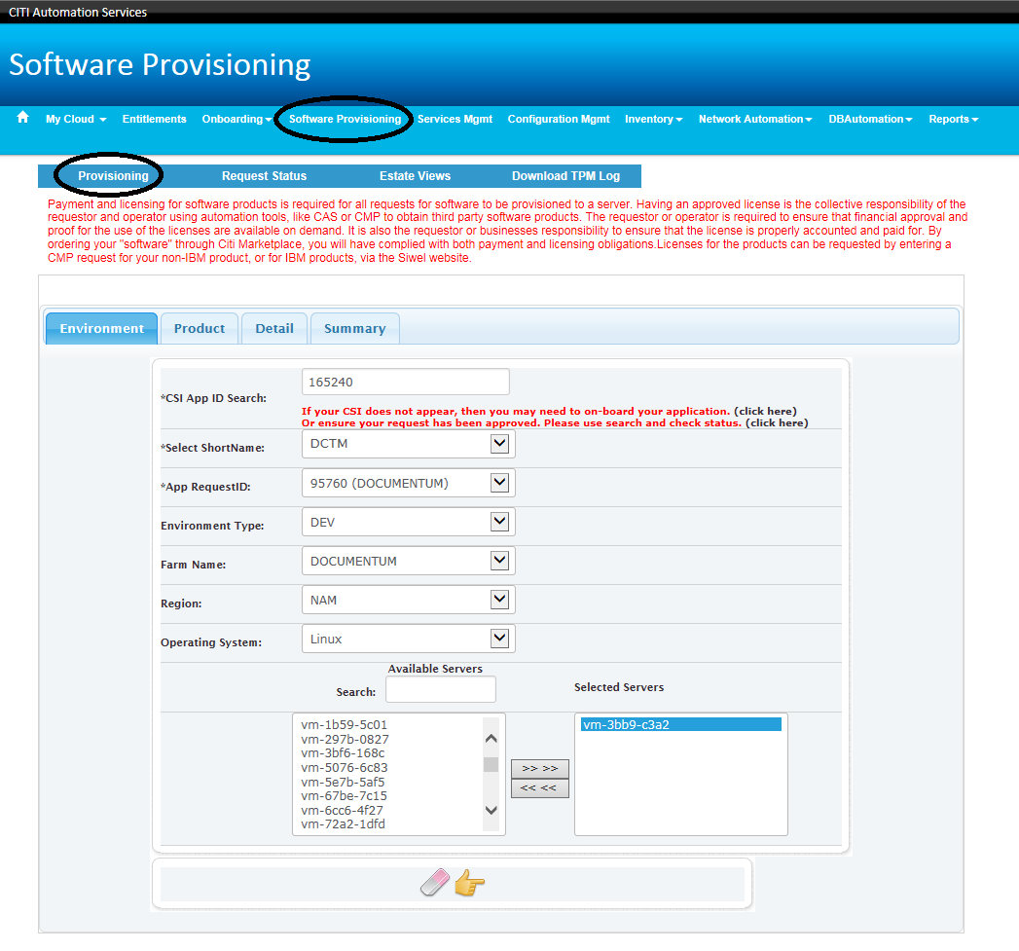

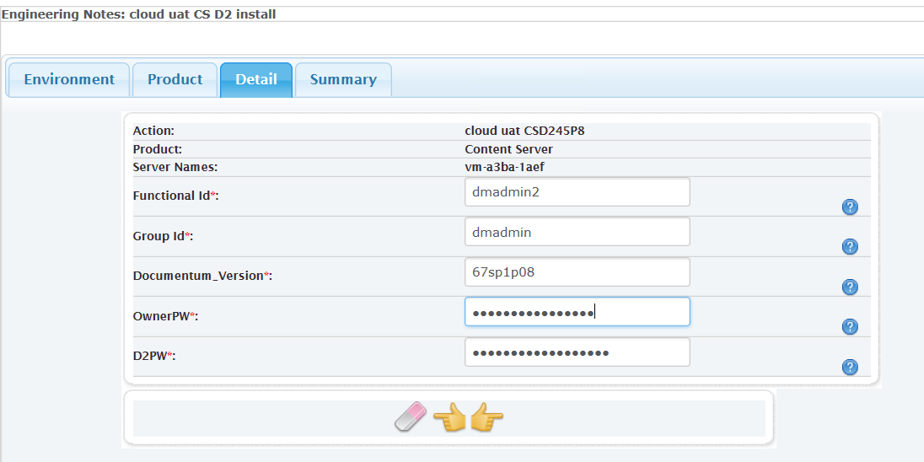
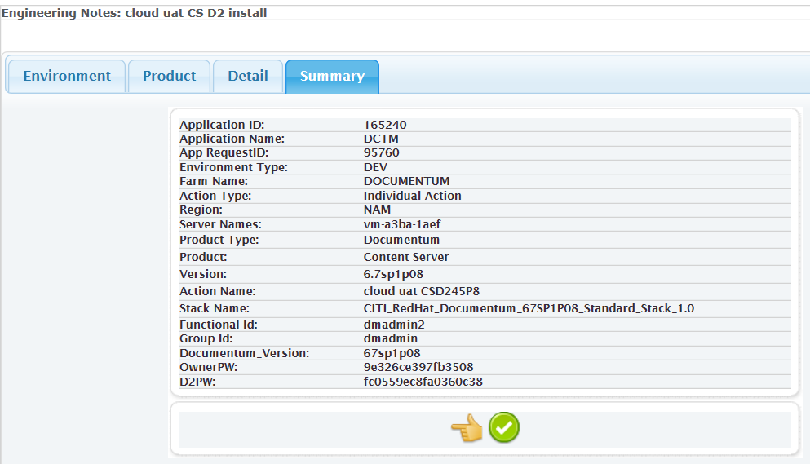

Then config at docbase level for the docbase using D2
three d2 dar files have to be install in globalstore and the docbase using d2. On the 2nd Content Server, it will create 2nd JMS object for the 2nd Content Server instance.
D2-DAR.dar, D2Widget-DAR.dar, Collaboration_Services.dar
check D2 dar install from DA
DA->Cabinets->System->Applications->D2->(show all objects and versions)->D2-DAR

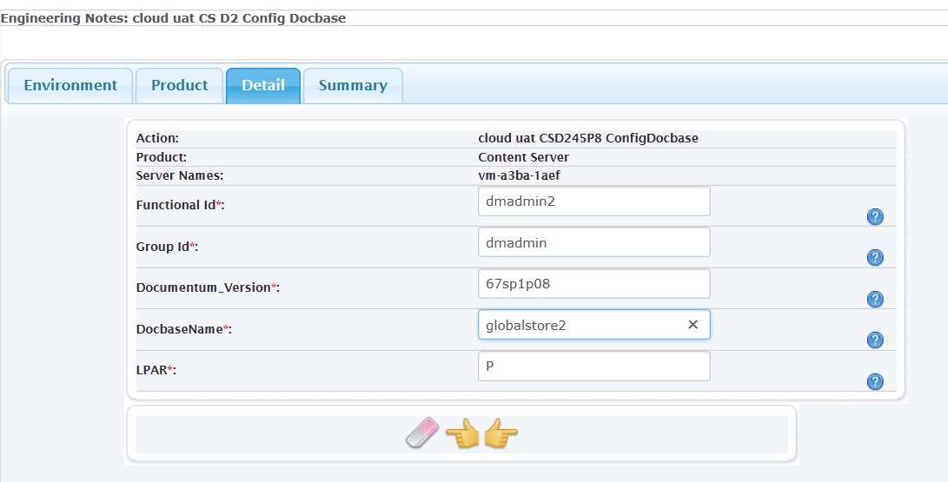
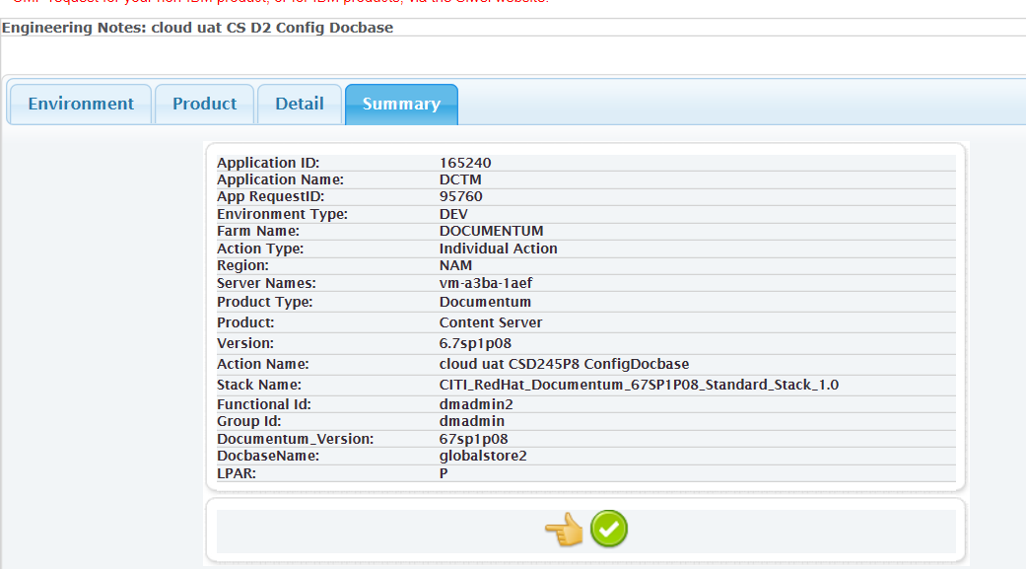

Check if dar install is good
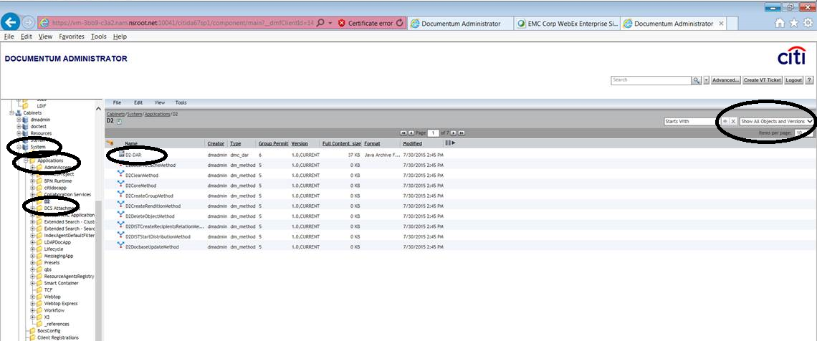

Note:
There is a dar file under $HOME/d2/dar/Collaboration_Services.dar.emc71
It has to be installed using Composer 71. The headless Composer is 67sp1 and can not be used.
There is Collaboration_Services.dar which is from D2 42 and is installed by CAS action and the test show no differece so far comaring to D2 45 Collaboration_Services.dar.emc71

App Server
If App Server is running on the same server as Content Server, they have to be in different FID. The reason is that it need env to generate lockbox on both sides.
If they are on differevent servers, then it is ok to have the same FID.
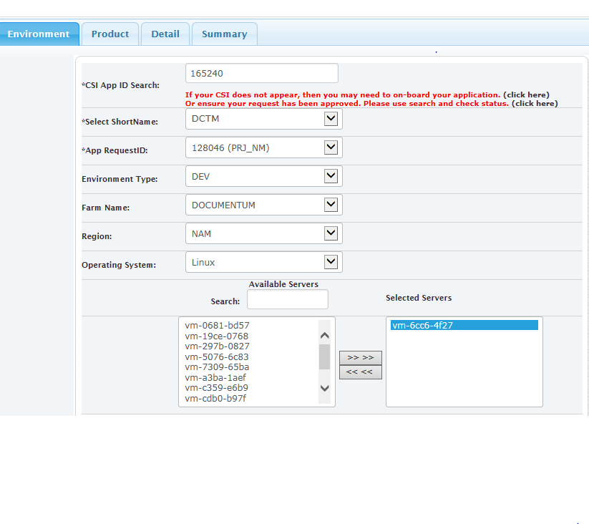

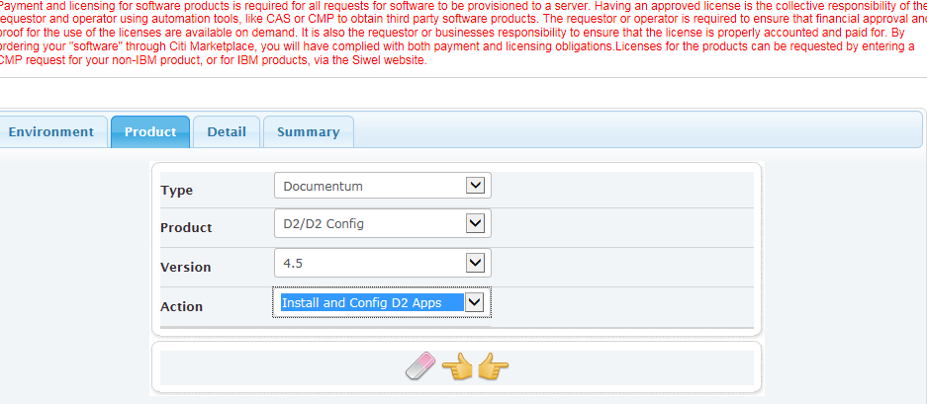

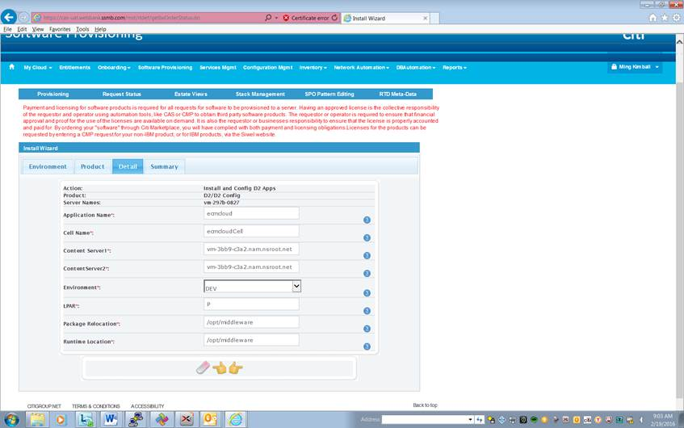
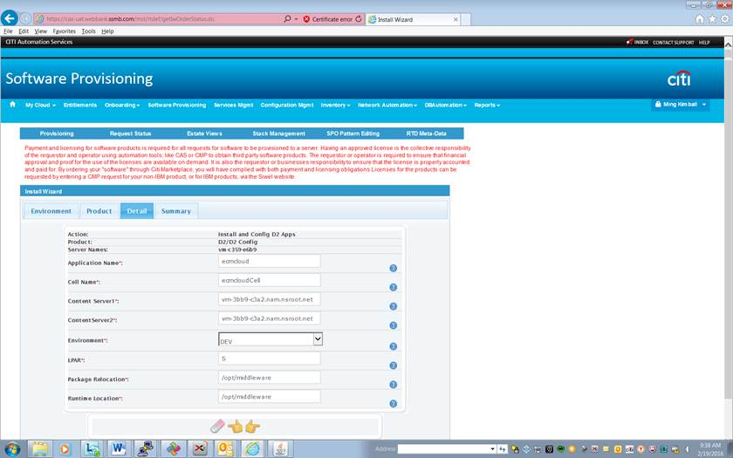

War file is only deplied from Node1 which has dmgr. Need to set up lockbox on both Node1 and Node2.

SSO set up
Refer to G:\SDMS\DOCUMENTUM CERTIFICATION\D2 4.5\Steps to up SSO for D245.docx
SSO config file:
webapps/D2/WEB-INF/classes/shiro.ini

Dedicated JMS for Docbase using D2
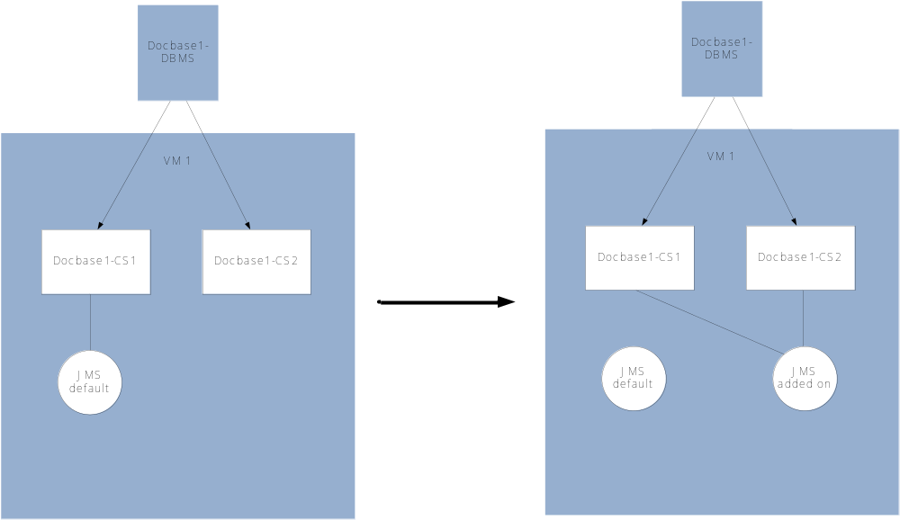

- Tar the default JMS dir and make the 2nd JMS dir assuming the default JMS already has D2 installed.
- In the 2nd jms dir, update the default 9080~9100 number to the new jms port num ~ port num+20
- Delete the default jms object then create all the content servers’ mapping objects to 2nd JMS
delete dm_jms_config object
dmbasic $DM_HOME/install/admin/dm_jms_config_setup.ebs -e installForRCS -- d2test.d2test2 dmadmin 5f38zeQf vm-3bb9-c3a2.nam.nsroot.net 9280 >mingjmsobj2nd1.log 2>&1
dmbasic $DM_HOME/install/admin/dm_jms_config_setup.ebs -e installForRCS -- d2test.d2test dmadmin 5f38zeQf vm-3bb9-c3a2.nam.nsroot.net 9280 >mingjmsobj2nd2.log 2>&1
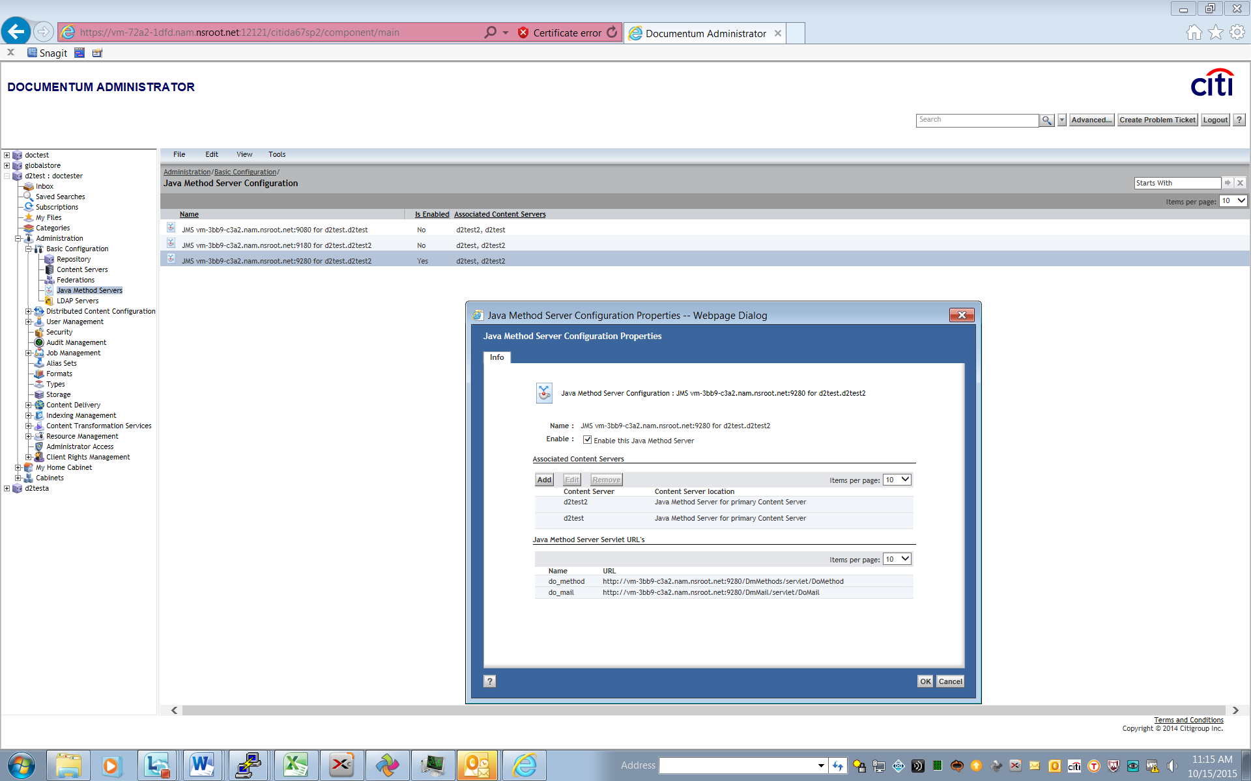
- Comment out the docbase acs entries in the default JMS acs.properties
- Create the acs object with the new JMS port numb and entires to the new JMS acs.properties
in PostDocbaseCreation.cfg
export JMS_PORTNUM=9280
export ACSPATH=$JMS_HOME/DctmServer_MethodServer_d2test/deploy/acs.ear/lib/configs.jar/config
ksh -x /opt/CITI_DCTMDocbaseSetup/default/scripts/create_acs_docbase.ksh d2test > mingacs2nd.log 2>&1
- Test
http://vm-3bb9-c3a2.nam.nsroot.net:9080/DmMethods/servlet/DoMethod
http://vm-3bb9-c3a2.nam.nsroot.net:9280/DmMethods/servlet/DoMethod
http://vm-3bb9-c3a2.nam.nsroot.net:9080/ACS/servlet/ACS
http://vm-3bb9-c3a2.nam.nsroot.net:9280/ACS/servlet/ACS
$ pwd
/home/dmadmin/CS67SP1/share/jboss5.1.0/server
$ ls -ltr start*.sh
-rwxr-xr-x 1 dmadmin dmadmin 289 Oct 6 15:28 startMethodServer.sh – default JMS
-rwxr-xr-x 1 dmadmin dmadmin 233 Oct 9 14:33 startJMS_HA.sh – JMS without D2
-rwxrwxr-x 1 dmadmin dmadmin 296 Oct 14 16:28 startMethodServer_d2test.sh – JMS with D2
$ ls -ltr stop*sh
-rwxr-xr-x 1 dmadmin dmadmin 212 Jul 1 14:24 stopMethodServer.sh
-rwxr-xr-x 1 dmadmin dmadmin 208 Oct 6 13:59 stopJMS_HA.sh
-rwxrwxr-x 1 dmadmin dmadmin 219 Oct 14 16:28 stopMethodServer_d2test.sh

Importing HR sample application
- need to create a user in admingroup for this user to be able to login to D2 config
create dm_user object set user_name = 'd2configuser', set user_login_name = 'd2configuser', set user_os_name = 'd2configuser', set user_address = 'CATE_Documentum_STE_DEV@imcnam.ssmb.com', set client_capability = 8, set user_privileges = 16, set user_group_name= 'admingroup', set default_folder = '/Temp', set user_source='inline password', set user_password='Welcome1'

- need to install "HR Config D2 4.2 - Export-Config.zip" from D2 config for user to be able to see interface from D2. Import HR.zip with install owner FID account.
File->Import Configuration->pick HR Config D2 4.2 - Export-Config.zip
Only select docapp on round 1
Then do a full import but unselect dar on round 2

- need to create a user in hr_group to use D2
create dm_user object set user_name = 'hruser', set user_login_name = 'hruser', set user_os_name = 'hruser', set user_address = 'CATE_Documentum_STE_DEV@imcnam.ssmb.com', set client_capability = 8, set user_privileges = 16, set user_group_name= 'hr_group', set default_folder = '/Temp', set user_source='inline password', set user_password='Welcome1'
create dm_user object set user_name = 'hr1user', set user_login_name = 'hr1user', set user_os_name = 'hr1user', set user_address = 'CATE_Documentum_STE_DEV@imcnam.ssmb.com', set client_capability = 8, set user_privileges = 16, set user_group_name= 'hr_consumer_group', set default_folder = '/Temp', set user_source='inline password', set user_password='Welcome1'
create dm_user object set user_name = 'hr2user', set user_login_name = 'hr2user', set user_os_name = 'hr2user', set user_address = 'CATE_Documentum_STE_DEV@imcnam.ssmb.com', set client_capability = 8, set user_privileges = 16, set user_group_name= 'hr_contributor_group', set default_folder = '/Temp', set user_source='inline password', set user_password='Welcome1'

- You may likely have c2/o2 errors still, and may need to install dars if you want to clear those. Its likely they aren’t fata. You could also just ignore them if you don’t want to install o2/c2 right now.

Error report :
Error importing switches for the c2_export_config modules (Type not found in the docbase).
Error importing switches for the c2_print_config modules (Type not found in the docbase).
Error importing switches for the c2_rendition_config modules (Type not found in the docbase).
Error importing switches for the c2_view_config modules (Type not found in the docbase).
Error importing switches for the o2_attribute_config modules (Type not found in the docbase).

There is a bug in P08 version for WF
EMC Documentum Service Request Management # 76199090 - Sending a Document to Workflow
fix it as below:
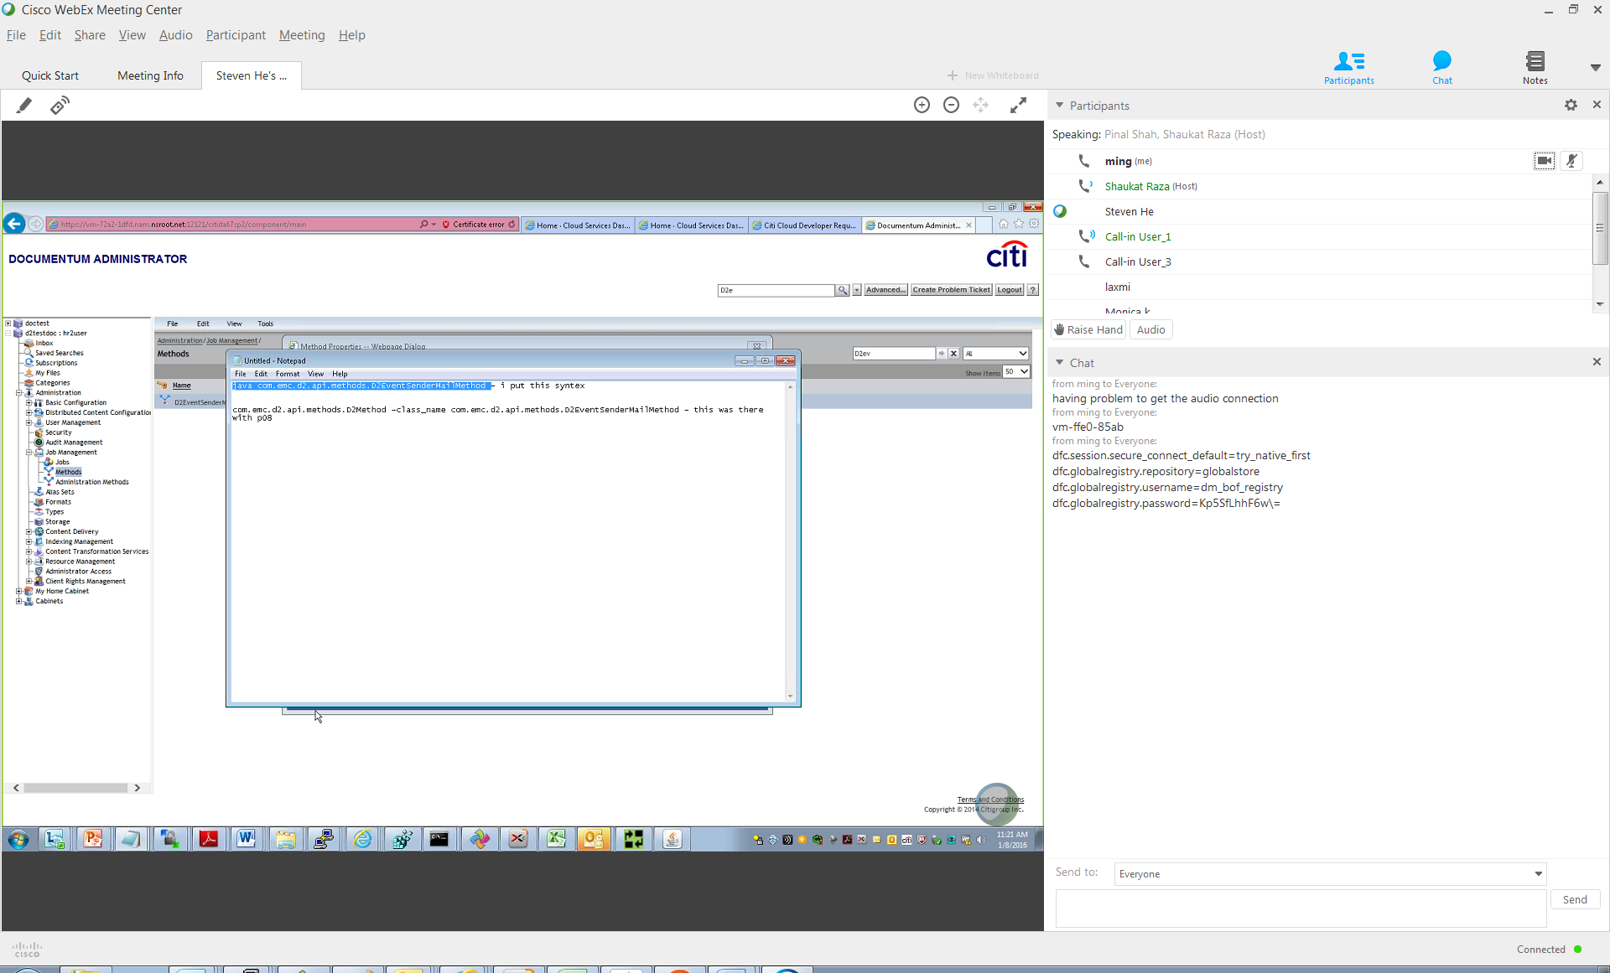
two workarounds on this issue for now

The first was to add the docbase_name as an argument in the D2EventSenderMailMethod
open method in DA and pass argument as below with your docbase name ( example )
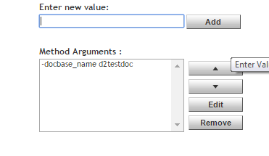
The second method was to revert the method verb to run as standalone ( not on JMS )
Currently the method verb for D2EventSenderMailMethod is as follows in D2 4.5 P08.
java com.emc.d2.api.methods.D2Method_class_name com.emc.d2.api.methods.D2EventSenderMailMethod
As a workaround, we have requested that you revert the method verb it back to
java com.emc.d2.api.methods.D2EventSenderMailMethod

GDS package for D2
/net/stealth/export1/home1.localhost/sw/Linux
-rw-r--r--+ 1 root root 1260193082 Jan 22 10:45 CITI_DCTMD2CSP8-1.0_A0-APPID.x86_64.rpm
-rwxrwxr-- 1 1000312 308 942080 Jan 19 14:35 CITI_RedHat_Documentum_Generic_Stack_1.0_CONFIGCSD2DOCBASEP8.tar
-rwxrwxr-- 1 1000312 308 942080 Jan 19 14:35 CITI_RedHat_Documentum_Generic_Stack_1.0_INSTALLCSD2P8.tar
CITI_DCTMD2AppP08-1.0_A0-165240.x86_64.rpm
CITI_RedHat_Documentum_Generic_Stack_1.0_DeployD2nD2ConfigAPPP08.tar

Siteminder package which contains the siteminder login page
$ yum list|grep smwa
smwa.x86_64 R12.0QMR3cr12_912-33975
-rwxr-xr-x+ 1 hermebld hermes 45008962 May 21 2012 smwa-6.0QMR5cr35_A3-33975.x86_64.rpm

Configurations/Logs Directories

Content Server
$DOCUMENTUM/../d2/api/logback.xml
$DOCUMENTUM/share/jboss5.1.0/server/DctmServer_MethodServer/deploy/ServerApps.ear/logback.xml
$DOCUMENTUM/share/jboss5.1.0/server/DctmServer_MethodServer/deploy/bpm.ear/classes/logback.xml
default under /opt/CITI_DCTMD2CSP8/log
/opt/CITI_DCTMD2CSP8/log/D2-CS.log
/opt/CITI_DCTMD2CSP8/log/D2-JMS.log

$DOCUMENTUM/share/jboss5.1.0/server/DctmServer_MethodServer/deploy/ServerApps.ear/APP-INF/classes/dfc.properties
$DOCUMENTUM/share/jboss5.1.0/server/DctmServer_MethodServer/deploy/ServerApps.ear/APP-INF/classes/D2-JMS.properties
$DOCUMENTUM/share/config/dfc.properties
$DOCUMENTUM/product/6.7SP1/install/composer/ComposerHeadless/plugins/com.emc.ide.external.dfc_1.0.0/documentum.config/dfc.properties

Docbase, JMS and ACS log:
$DOCUMENTUM/dba/log/<docbase>.log
$DOCUMENTUM/share/jboss5.1.0/server/DctmServer_MethodServer/log/server.log
$DOCUMENTUM/share/jboss5.1.0/server/DctmServer_MethodServer/logs/acs.log

App Server
/opt/middleware/d245/d245_Runtime/profiles/d245Cell/d245Profile/installedApps/d245Cell/D2.ear/D2.war/WEB-INF/classes/dfc.properties
/opt/middleware/d245/d245_Runtime/profiles/d245Cell/d245Profile/installedApps/d245Cell/D2.ear/D2.war/WEB-INF/classes/D2FS.properties
/opt/middleware/d245/d245_Runtime/profiles/d245Cell/d245Profile/installedApps/d245Cell/D2.ear/D2.war/WEB-INF/classes/logback.xml

/opt/middleware/d245/d245_Runtime/profiles/d245Cell/d245Profile/installedApps/d245Cell/D2-Config.ear/D2-Config.war/WEB-INF/classes/dfc.properties
/opt/middleware/d245/d245_Runtime/profiles/d245Cell/d245Profile/installedApps/d245Cell/D2-Config.ear/D2-Config.war/WEB-INF/classes/D2-Config.properties
/opt/middleware/d245/d245_Runtime/profiles/d245Cell/d245Profile/installedApps/d245Cell/D2-Config.ear/D2-Config.war/WEB-INF/classes/logback.xml

/opt/middleware/d245/d245_Runtime/profiles/d245Cell/d245Dmgr/logs/dmgr/SystemOut.log
/opt/middleware/d245/d245_Runtime/profiles/d245Cell/d245Profile/logs/d245Server/TextLog_15.10.01_10.46.36.log

Default under /opt/CITI_DCTMD2AppP08/log
/opt/CITI_DCTMD2AppP08/log/D2.log
/opt/CITI_DCTMD2AppP08/log/D2-Config.log

SSO config
/opt/middleware/d245/d245_Runtime/profiles/d245Cell/d245Profile/installedApps/d245Cell/D2.ear/D2.war/WEB-INF/classes/shiro.ini
--------------------------
[main]
X3-TrustedReverseProxy=com.emc.x3.portal.server.filters.authc.X3TrustedReverseProxyHttpAuthenticationFilter
#X3-TrustedReverseProxy.defaultRepository = doctest
X3-TrustedReverseProxy.endToEndSolution=true
X3-TrustedReverseProxy.userParameterHeaderName=SM_USER
X3-TrustedReverseProxy.logonForm=login.fcc
X3-TrustedReverseProxy.ecsPlugIn=dm_netegrity
X3-TrustedReverseProxy.sessionCookieName=SMSESSION
/** = X3-TrustedReverseProxy
-------------------------
if X3-TrustedReverseProxy.endToEndSolution=false
need below:
a) /opt/middleware/d245/d245_Runtime/profiles/d245Cell/d245Profile/installedApps/d245Cell/D2.ear/D2.war/WEB-INF/classes/d2fs-trust.properties
--------------------------
*.user=dmadmin
*.domain=
--------------------------
b) java com.emc.common.java.crypto.SetLockboxProperty $DOCUMENTUM/D2/Lockbox D2FS-trust.${DOCBASE_NAME}.password $INSTALLOWNER_PW
Option 1 - X3-TrustedReverseProxy.endToEndSolution=false
"SSO authentication for the application server" uses DFC Principal Authentication mode which creates Content Server login tickets on behalf of the authenticated users. This authentication does not require any authentication plugins or configuration on the Content Server DFC Principal authentication is setup and configured on the application server and doesn't have components dependent on the content server.
Option 2 - X3-TrustedReverseProxy.endToEndSolution=true
"SSO authentication for the app and CS" does have specific components dependent on the content server This authentication requires an appropriate authentication plugin to be installed and configured on the Content Server. In this authentication mode, D2 uses an SSO token issued by the SSO provider (Kerberos, RSA Access Manager, or CA SiteMinder) as a credential when obtaining a session on the Content Server on behalf of a user, and the Content Server authenticates this token before granting a session to the D2 application server.

Sample URL
SSO
https://ecmd2.nam.nsroot.net:7080/D2
lj0311/autumnxx
IHS
https://vm-3bb9-c3a2.nam.nsroot.net:7080/D2
HTTPS:
https://vm-3bb9-c3a2.nam.nsroot.net:12061/D2-Config/
d2configuser/Welcome1
https://vm-3bb9-c3a2.nam.nsroot.net:12061/D2
hruser/Welcome1
hr1user/Welcome1
hr2user/Welcome1
HTTP:
http://vm-3bb9-c3a2.nam.nsroot.net:12060/D2-Config/
http://vm-3bb9-c3a2.nam.nsroot.net:12060/D2

WebSphere Admin console URL:
https://vm-3bb9-c3a2.nam.nsroot.net:10001/ibm/console/
dctmwas_admin/alakazotland123(DA) ) – Fid dmadmin
https://vm-3bb9-c3a2.nam.nsroot.net:12001/ibm/console
d245Admin/alakazotland123(D2) ) – Fid dmadmin2
DA
https://vm-3bb9-c3a2.nam.nsroot.net:10041/citida67sp1/
dmadmin/5xxxxf
doctester/Welcome1
/export/wasapps/dctmwas7/dctmwas7_Runtime/profiles/dctmwas_Cell/dctmwas_node01/installedApps/dctmwas_Cell/citida67sp1.ear/citida67sp1.war/WEB-INF/classes/dfc.properties
https://vm-72a2-1dfd.nam.nsroot.net:12001/ibm/console (dctmappsAdmin/alakazotland123) – Fid dmadmin
https://vm-72a2-1dfd.nam.nsroot.net:12121/citida67sp2 (pointed to vm-3bb9-c3a2)

WAS 2 nodes env:
https://vm-297b-0827.nam.nsroot.net:15001/ibm/console
ecmcloudAdmin/alakazotland123
node1:
https://vm-297b-0827.nam.nsroot.net:15121/D2/#d2
https://vm-297b-0827.nam.nsroot.net:15121/D2-Config
Node2
https://vm-c359-e6b9.nam.nsroot.net:15121/D2/#d2
https://vm-c359-e6b9.nam.nsroot.net:15121/D2-Config

back out plans
Mention briefly the procedure for back out plan.
Roll back the directories below
Content Server:
CS67SP1/D2
CS67SP1/D2/Lockbox
CS67SP1/share/jboss5.1.0/server/DctmServer_MethodServer/deploy/ServerApps.ear
CS67SP1/share/jboss5.1.0/server/DctmServer_MethodServer/deploy/bpm.ear
d2
D2_4.5.0_P08
emc-dfs-sdk-6.7

App Server:
D2/Lockbox
D2/war
"HR Config D2 4.2 - Export-Config.zip"

Glossary
Define all Acronyms and Business Terms that are used in this document where the definition would not be widely known, for example, CDB – Central Database - the main data repository for a specific department.

Term or Acronym | Explanation or Definition
COB | Continuity Of Business
PCM | Product Development Process Control Manual
URC | Universal Record Classification
VTM | Vulnerability Threat Management

APPENDICES
Include any local requirements, such as any processes, procedures or requirements that are specific to your organization. Indicate the document name, and link to the document where it is stored.
Test Class / Type | Definition
Functional Testing | Testing software based on its functional requirements. It ensures that the program physically works the way it was intended and all required menu options are present. It also ensures that the program conforms to the industry standards relevant to that environment; for example, in a Windows program, pressing F1 brings up help. In this type of testing, the system is validated for its functional behavior. Functional testing does not deal with internal coding of the project.
Information Security / VA Testing | Information security assessment is the process of determining how effectively an entity being assessed (e.g., host, system, network, procedure, person—known as the assessment object) meets specific security objectives. Information Security / VA Testing confirms how well a system protects itself against unauthorized internal or external, or willful damage of code. Security testing assures that the program is accessed by the authorized only.
Non-Functional Testing | Testing the attributes of a component or system that do not relate to functionality, e.g. reliability, efficiency, usability, maintainability, and portability.
Parallel Testing / Production Assurance Testing | This type of testing ensures that a new application which has replaced its older version has been installed and is running correctly. Parallel Testing / Production Assurance Testing (PAT) allows the user to perform a final check and confirm functionality, volume, accuracy, interfaces, etc. based on business requirements, using production data.
System Integration Testing (Including: Interface Testing, Batch Testing) | System integration testing (SIT) is a testing process that exercises a software system's coexistence with others. With multiple integrated systems, assuming that each have already passed system testing, SIT proceeds to test their required interactions. Following this, the deliverables are passed on to acceptance testing. System Integration Testing verifies combined functionality.
Technology Testing | Refers to all testing performed by the technology staff.
Integration Testing | (IEEE 610) The testing of individual software components. Integration Testing is done at the developer's site to check whether a particular piece/unit of code is working as designed.
User Acceptance Testing | User Acceptance Testing typically entails providing the application to the intended user, customer or other authorized party, before the application is approved for release into production. The testers validate end-to-end business processes, comparing with actual intended use.

FAQ

MSXML ActiveX required for D2 Config
First time login to D2 Config it asked for MSXML ActiveX install, selected to install. Since did not have admin rights, ActiveX is NOT installed in the VDI.
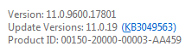
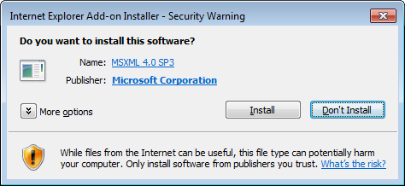
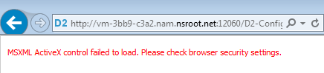

Above issues resolved by following actions →
Raised ticket with citi helpdesk team regarding the IE issue for D2-Config/D2 (MSXML ActiveX install requirement)

The admin did the following step:
Closed all IE sessions open.
Internet Options → Security → Sites tab in all 3 (Internet/Local Intranet/Trusted Sites)
Allowed all Add-Ons to be enabled. Cleared cache/temp cookies and restarted IE.
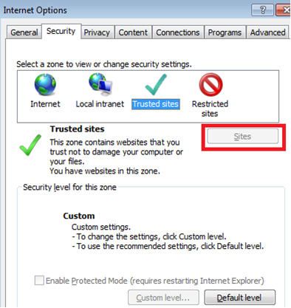
Now able to open and login to D2-Config.

https link works but not http link for D2
Got this error when click on D2 http link
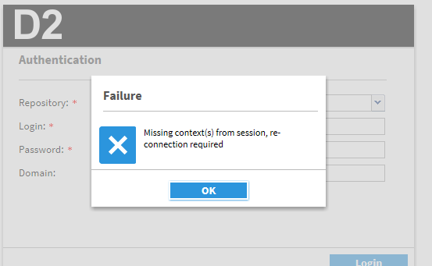
Disable the restrict cookies in WAS should solve the issue.
Disable the Restrict cookies to HTTPS sessions setting. To view this administrative console page, click Servers > Application Servers > server_name > Web Container > Session Management > Enable Cookies.
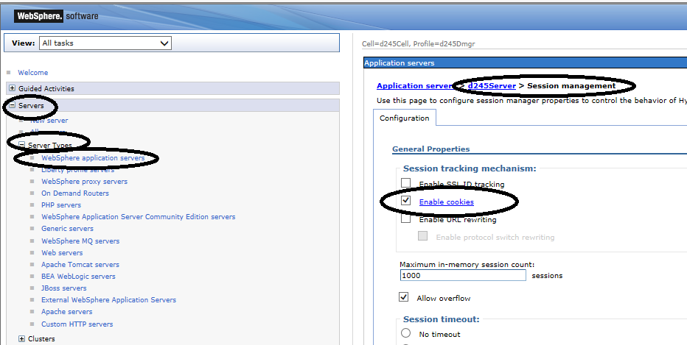

All the CS need JMS mapping to
“No Java Method Server available to server the request” is caused by 2nd CS does not have mapping JMS object. Please fix it from DA

Only D2Method.passphrase is required for lockbox
CS:
export CLASSPATH=$DOCUMENTUM/share/config:$DOCUMENTUM/share/jboss5.1.0/server/DctmServer_MethodServer/deploy/bpm.ear/APP-INF/classes/D2.lockbox:$DOCUMENTUM/../d2/api/D2.jar:$DOCUMENTUM/../d2/api/LB.jar:$DOCUMENTUM/../d2/api/LBJNI.jar:$CLASSPATH
export PATH=$DOCUMENTUM/D2/Lockbox/linux_gcc34_ia32:$PATH
export LD_LIBRARY_PATH=$DOCUMENTUM/D2/Lockbox/linux_gcc34_ia32:$LD_LIBRARY_PATH
/opt/dmadmin/CS67SP1/share/java/1.6.0_27/bin/java com.emc.common.java.crypto.SetLockboxProperty $DOCUMENTUM/D2/Lockbox D2Method.passphrase $LOCKBOXJMS_PW

Clean up lockbox
mv $DOCUMENTUM/D2/Lockbox/D2.lockbox.bak.FCD $DOCUMENTUM/D2/Lockbox/D2.lockbox.bak.FCD.$DT
mv $DOCUMENTUM/D2/Lockbox/D2.lockbox.bak $DOCUMENTUM/D2/Lockbox/D2.lockbox.bak.$DT
mv $DOCUMENTUM/D2/Lockbox/D2.lockbox.FCD $DOCUMENTUM/D2/Lockbox/D2.lockbox.FCD.$DT
mv $DOCUMENTUM/D2/Lockbox/D2.lockbox $DOCUMENTUM/D2/Lockbox/D2.lockbox.$DT
recopy:
cp $DOCUMENTUM/D2/Lockbox/D2.lockbox $DOCUMENTUM/share/jboss5.1.0/server/DctmServer_MethodServer/deploy/ServerApps.ear/APP-INF/classes
cp $DOCUMENTUM/D2/Lockbox/D2.lockbox $DOCUMENTUM/share/jboss5.1.0/server/DctmServer_MethodServer/deploy/bpm.ear/APP-INF/classes

APP:
export CLASSPATH=/opt/middleware/d245/d245_Runtime/profiles/d245Cell/d245Profile/installedApps/d245Cell/D2-Config.ear/D2-Config.war/WEB-INF/lib/C6-Common-4.5.0.jar:/home/dmadmin2/D2/Lockbox/lib/LB.jar:/home/dmadmin2/D2/Lockbox/lib/LBJNI.jar:$CLASSPATH
export LD_LIBRARY_PATH=/home/dmadmin2/D2/Lockbox/lib/native/linux_gcc34_x64:$LD_LIBRARY_PATH
export PATH=/home/dmadmin2/D2/Lockbox:/home/dmadmin2/D2/Lockbox/lib/native/linux_gcc34_x64:$PATH
/opt/middleware/d245/WebSphere/85-64/java/bin/java com.emc.common.java.crypto.SetLockboxProperty $HOME/D2/Lockbox D2Method.passphrase $LOCKBOXJMS_PW

Cleanup is the same as CS, no need to recopy
Other missing entries in Lockbox are all warnings

Cache clean up
CS:
$DOCUMENTUM/share/cache
cd /tmp; rm -rf *cache.data; rm -rf xml-cache.index;
> /opt/CITI_DCTMD2CSP8/log/D2-CS.log
> /opt/CITI_DCTMD2CSP8/log/D2-JMS.log

JMS cache:
DctmServer_MethodServer/tmp
DctmServer_MethodServer/work

APP:
/opt/middleware/d245/d245_Runtime/profiles/d245Cell/d245Profile/Documentum
Node1:
cd /tmp/d2app; rm -rf *cache.data; rm -rf xml-cache.index;
Node2:
cd /tmp; rm -rf *cache.data; rm -rf xml-cache.index;
> /opt/CITI_DCTMD2AppP08/log/D2.log
> /opt/CITI_DCTMD2AppP08/log/D2-Config.log

How to change D2/D2 Config APP cache location
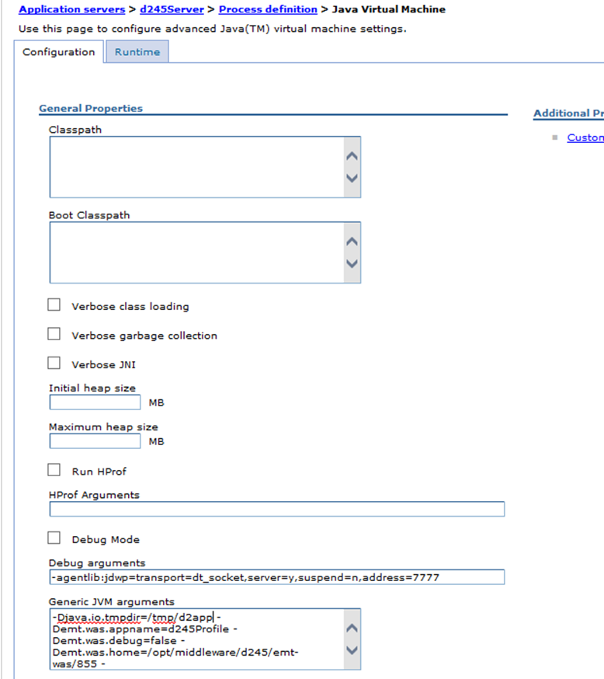

Default location is /tmp, redefined to /tmp/d2app

Simple way to test D2/D2 Config
Help -> About
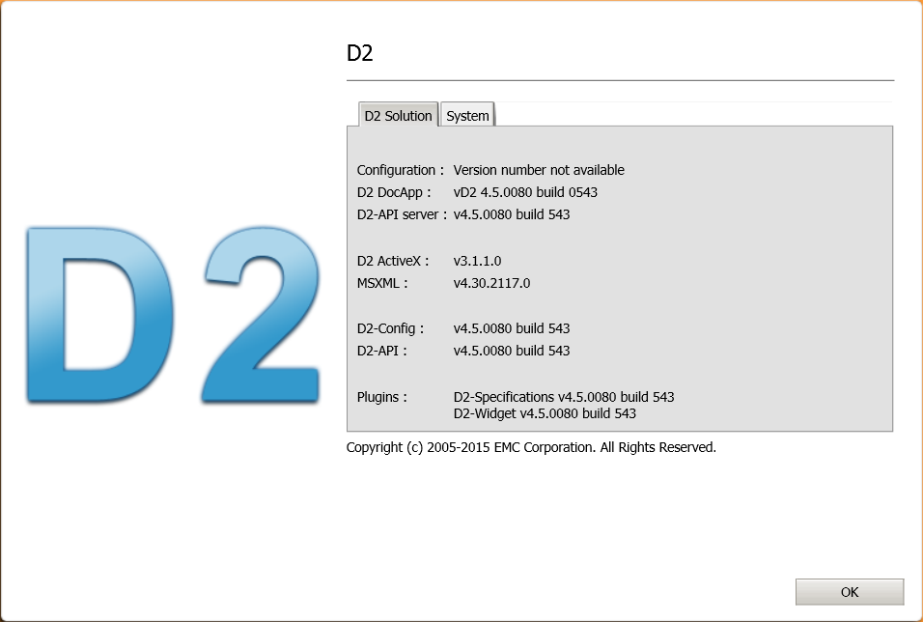
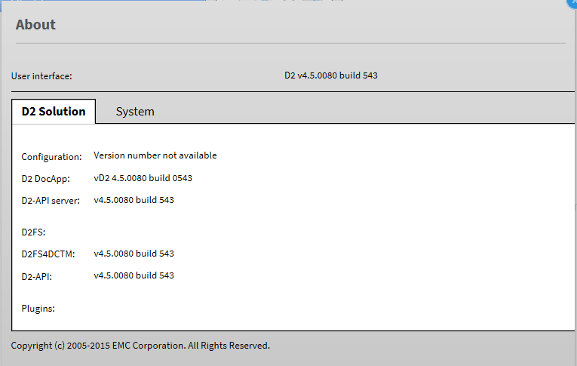

D2 Config only supports IE 32bit version
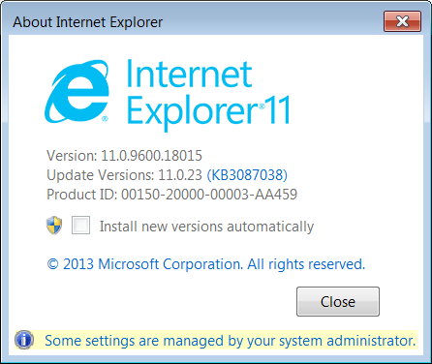

How to turn debug on D2
/opt/middleware/d245/d245_Runtime/profiles/d245Cell/d245Profile/installedApps/d245Cell/D2.ear/D2.war/WEB-INF/classes/D2FS.properties

This define the log location:
/opt/middleware/d245/d245_Runtime/profiles/d245Cell/d245Profile/installedApps/d245Cell/D2.ear/D2.war/WEB-INF/classes/logback.xml
<appender class="ch.qos.logback.core.rolling.RollingFileAppender" name="RootFileAppender">
<file>/tmp/D2.log</file>
<append>true</append>
<filter class="ch.qos.logback.classic.filter.ThresholdFilter">
<level>debug</level>
</filter>

1) Enable a joint authentication and ticket trace with the API commands below
apply,c,NULL,SET_OPTIONS,OPTION,S,trace_authentication,VALUE,B,T
apply,c,NULL,SET_OPTIONS,OPTION,S,ticket_trace,VALUE,B,T
2) Reproduce the error
3) Disable the authentication and ticket trace with the commands below
apply,c,NULL,SET_OPTIONS,OPTION,S,ticket_trace,VALUE,B,F
apply,c,NULL,SET_OPTIONS,OPTION,S,trace_authentication,VALUE,B,F
4) Provide the docbase log with tracing information
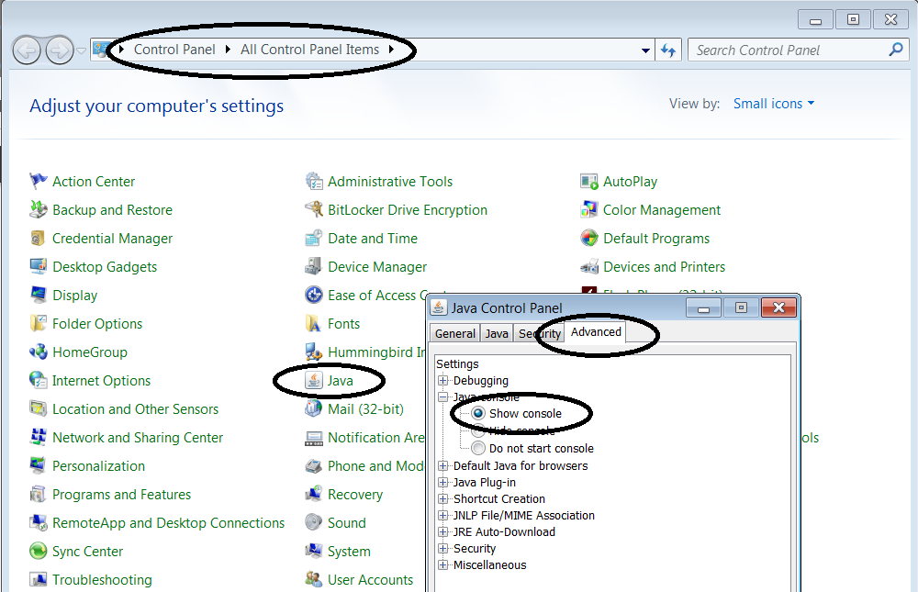

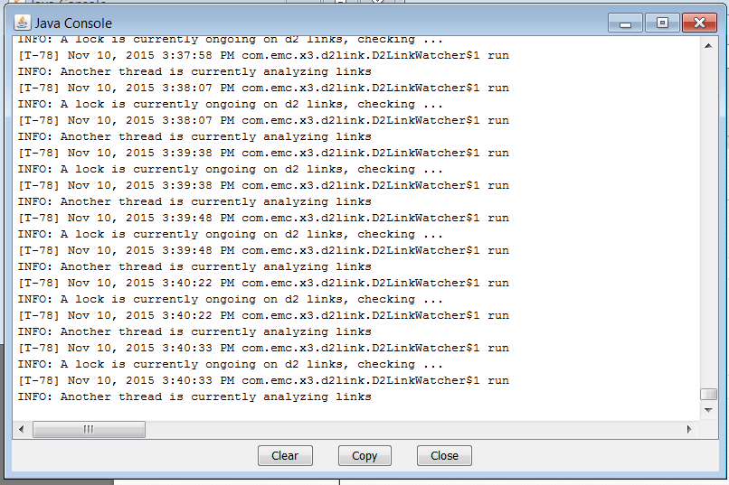

How to add patch and handle OS upgrade
When you use new patch war file, update the value in the ini/property files, do not copy the old one from early version
If OS upgrade, you may need to regenerate lockbox
CS:
/opt/CITI_DCTMD2CSP8/scripts/runlockboxcs.ksh
APP: (just need to run the last line)
/opt/CITI_DCTMD2AppP08/scripts/setlockboxapp.ksh

How to test D2 and D2-Config
D2: import a document or modify a document
D2-Config ->tool->options
Check and uncheck something -> save
Just want to see the msg in the D2-Config.log

Lockbox lib shared between D2 and D2 Config
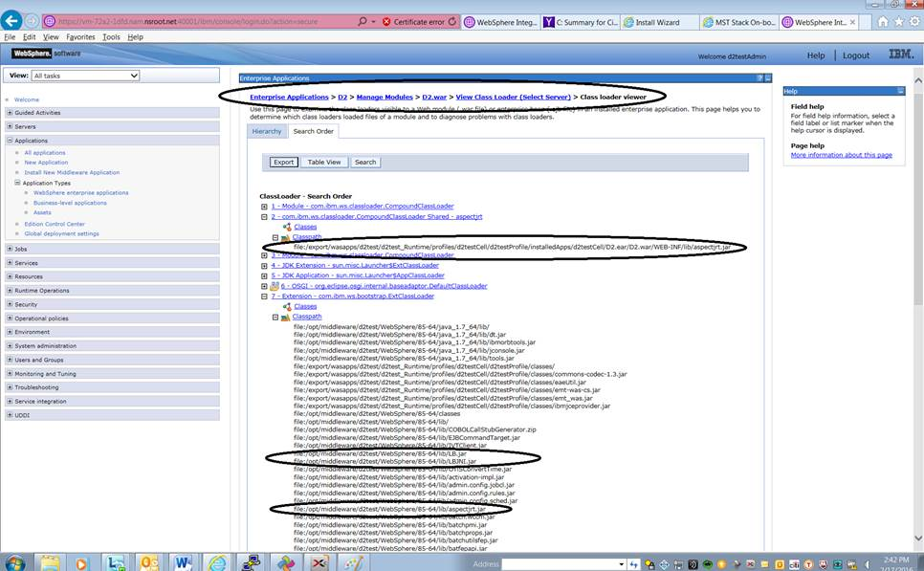

This is for generate lockbox
. ./.D2APPENV.env
$ cat .D2APPENV.env
export CLASSPATH=/export/wasapps/d2test/d2test_Runtime/profiles/d2testCell/d2testProfile/installedApps/d2testCell/D2-Config.ear/D2-Config.war/WEB-INF/lib/C6-Common-4.5.0.jar:/opt/CITI_DCTMD2AppP08/d245/Lockbox/lib/LB.jar:/opt/CITI_DCTMD2AppP08/d245/Lockbox/lib/LBJNI.jar:$CLASSPATH
export LD_LIBRARY_PATH=/opt/CITI_DCTMD2AppP08/d245/Lockbox/native/linux_gcc34_x64:$LD_LIBRARY_PATH
export PATH=/opt/CITI_DCTMD2AppP08/d245/Lockbox:/opt/CITI_DCTMD2AppP08/d245/Lockbox/native/linux_gcc34_x64:$PATH

D2 login page blank without this
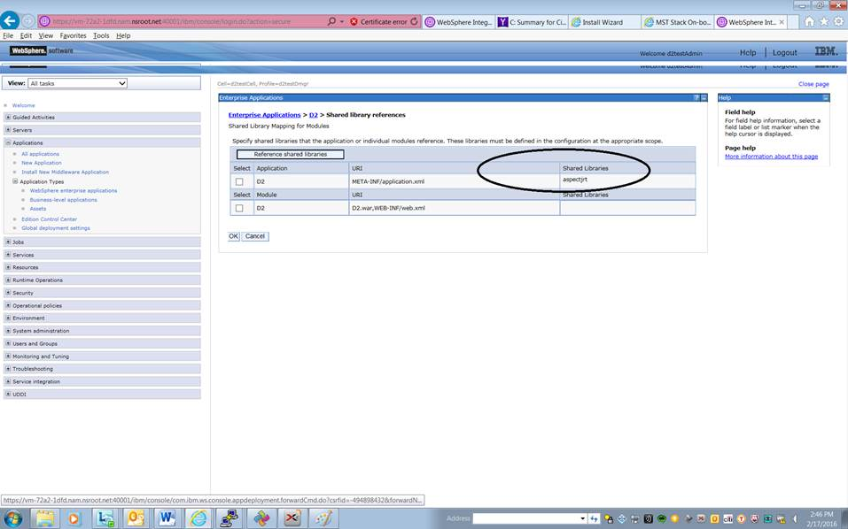
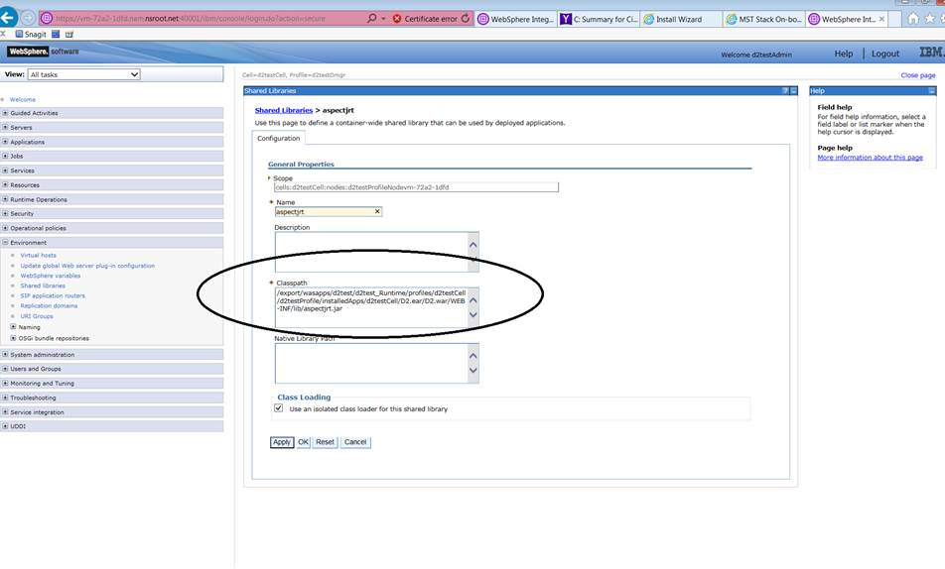

Clean Documentum cache in your PC
If you see below message, clean Documentum cache in your PC
